

“From Pita to Profits: An Analysis of CAVA’s position in the Fast-Casual Space”
Course: MAR4613-0003 - Marketing Research
Group Members: Jacqulyn Kepple, Robbie Fishbein, Luke Corsinita, Rachel Fernandez, Luke Svendsen, Ashley Sprague
Assignment: Final Group Project
Date: April 28th, 2025

TABLE OF CONTENTS

SECTION TITLE PAGE
Executive Summary ………….……………………………..……………………………………6
Introduction…………………………………………………………………..…………..……….9
A Brief History of CAVA………………………………………………………….……...9
Sales Trends………………………….….……….……………………………….……...10
Competition Landscape………………….……..………………………………………..11
Legal Considerations………………………...………………………………………..…14
Social-Cultural Issues……………….…………………………………….…………..…15
Economic Trends…………………………..………..……………….………………..…17
Segmentation Analysis…..…………………..…..…………………………………...…..18
Research Objectives…………………………………………...…………………………20
Methodology………………………………..…………………………………………………....21
Data Analysis & Results……………………………...………………………………………....23
Profile of Sample………………………….………………………..…………………... 23
Descriptive Results………………………………………………………………………29
Difference & Association Analysis……………………………………….……………..36
Limitations…………………………………………………………………………………….....50
Conclusions & Recommendations…………….…………………………………..……………52
References………………………………….……………………………………………...…….59
Appendix………………………………………………………………………………………....62

LIST OF ILLUSTRATIONS
FIGURES PAGE
Figure 1.0: Respondent’s Age Range……………………………………………………………24
Figure 2.0: Respondent’s Gender Distribution…………………………..………………………25
Figure 3.0: Respondent’s Marital Status…………………………..……………………….….…26
Figure 4.0: Respondent’s Before-Tax Household Income……………………………...……….28
Figure 5.0: One Word Impressions of CAVA………………………………………………...…29
Figure 1.1: Average Time Spent in CAVA …………………………………………………..…31
Figure 2.1: Average Weekly Fast-Casual Dining Frequency………..………………..…………32
Figure 3.1: Impact of Legal Concerns on Perceptions………..……………………….…………33
Figure 5.1: Willingness to Pay …………………………..………...…… ………………………34
Figure 6.1: Factors Influencing Purchase Intent…………………..…………………..…………35
Figure 1.2: Impact of Location Proximity on the Customer Experience……………………...…37
Figure 1.3: Store Layout Comparison – CAVA vs. Chipotle…………..……... ………………..38
Figure 1.4: Average Time Spent in CAVA & Visiting Key Store Area……… ………………..39
Figure 2.2: Impact of Food Quality on Overall Satisfaction……………………… ……………40
Figure 2.3: Impact of Dining at CAVA on Competitive Ranking…………...…………….…….41
Figure 3.2: False Advertising Threat Ranking by Marital Status………………………..………42
Figure 3.4: Impact of Legal Threats on Purchase Intent by Marital Status………………...……44
Figure 5.2: Current Perceived Economic Value of CAVA ……………………………...………45
Figure 5.3: Competitor Comparison of Willingness to Pay……………………………...………46
Figure 6.2: CAVA Visits & Social Media Ad Exposure…………………………………...……48
Figure 6.4: Factors Influencing Purchase Intent by Gender ……………………….……………50
TABLES PAGE
Table 2.4: Consideration Set Volume & Age …………… …………………………...………...41
Table 3.3: Belief in Impact of Legal Issues & Before-Tax Household Income……........………43
Table 5.4: Competitive Value & Willingness to Spend …………..… …………………….……47
Table 6.3: Month CAVA Dining Frequency & Age……………..……… …………………...…49

EXECUTIVE SUMMARY

Overview
This study was conducted by a group of Florida State University students to explore consumer perceptions of CAVA and uncover opportunities for growth in the fast-casual dining market. The research aimed to evaluate CAVA’s expansion potential, brand positioning, customer satisfaction, pricing strategy, legal risks, and consumer segmentation. Findings suggest that CAVA is well-regarded by consumers familiar with the brand, with strong satisfaction scores related to food quality and service. CAVA ranks competitively among fast-casual options, particularly among consumers who prioritize health-conscious and customizable dining. Insights into store layout and expansion preferences indicate that thoughtful physical growth strategies can strengthen brand accessibility and visibility. Additionally, the study revealed that legal and socio-cultural issues, such as food safety and environmental claims, can influence customer trust and brand loyalty. Consumers generally perceive CAVA’s pricing to be fair, with most willing to spend $15–$20 per visit, though pricing sensitivity is influenced by economic perceptions. The research also identified distinct consumer segments based on attitudes toward health, value, and brand transparency, offering CAVA valuable direction for more tailored marketing. Overall, the findings provide strategic insights for enhancing CAVA’s market presence, consumer connection, and long-term competitiveness.

Objectives
In this study, we evaluated how consumers perceive the CAVA brand within the fast-casual dining industry. Our goal was to analyze CAVA’s growth potential, brand positioning, and customer satisfaction compared to competitors. We explored how legal issues, pricing strategies, and socio-cultural trends influence consumer trust and purchasing decisions. Additionally, we aimed to understand CAVA’s core consumer segments and identify ways the brand can better target and engage them.

Statement of Methods
A survey was conducted with a sample of 100 respondents. No demographic restrictions were applied in order to ensure a diverse sample. The data was collected using Qualtrics and analyzed using SPSS. The majority of respondents (66%) were aged 20-40, and the sample was primarily (64%) female.

Findings & Recommendations
- Strong Brand Perception Among the Informed
  - Finding: Respondents who had heard of or visited CAVA rated it highly in terms of freshness, flavor, and healthiness.
  - Recommendation: CAVA should increase brand awareness through digital and in-store marketing, especially in new markets, to capitalize on its strong brand perception once discovered.
- Top-of-Mind Competitors: Chipotle & Sweetgreen
  - Finding: Respondents most often compared CAVA to Chipotle, Sweetgreen, and Panera Bread.
  - Recommendation: CAVA should clearly differentiate itself in messaging, emphasizing Mediterranean cuisine, sustainability, and plant-based options, to carve a unique identity.
- Perceived as Reasonably Priced
  - Finding: The majority of respondents were comfortable spending $15–$20 per visit, which aligns with CAVA’s pricing model.
  - Recommendation: Reinforce this value perception by highlighting portion size, ingredient quality, and meal customization in marketing.
- Physical Store Layout Matters
  - Finding: Cleanliness, efficient service flow, and easy-to-understand ordering processes were critical to positive dining experiences.
  - Recommendation: Standardize and optimize store layouts and signage to enhance first-time user comfort and efficiency.
- Legal Concerns Can Damage Trust
  - Finding: Legal concerns around food safety and false environmental claims were flagged as potential brand risks.
  - Recommendation: Stay ahead of regulatory trends and maintain rigorous compliance, while using third-party certifications to build credibility.
- Socio-Cultural Trends Drive Brand Loyalty
  - Finding: Consumers are increasingly aligning food choices with personal values like health, sustainability, and social justice.
  - Recommendation: Align brand messaging with these values through storytelling campaigns and partnerships with mission-driven organizations.
- Distinct Consumer Segments Identified
  - Finding: Attitudinal segmentation revealed clusters such as “Health-Conscious Explorers” and “Value-Driven Pragmatists.”
  - Recommendation: Use these insights to personalize email marketing, in-app recommendations, and localized ad content to better resonate with each segment.

INTRODUCTION

A Brief History of CAVA
In 2006, Ike Grigoropolous, Ted Xenohristos, and Chef Dimitri Moshoviti founded CAVA and opened their first restaurant in Washington, D.C, aiming to introduce Mediterranean dining to the area. The founders had known each other since they were six, and shared a strong background in food and hospitality, emphasizing these values in their lives. A few years after founding CAVA, they met Brett Schulman, who joined the team as CEO. With a vision of making CAVA a national brand and leveraging his business insights, Schulman guided the company towards success.
CAVA’s strategy focuses on reducing food costs by maintaining a limited menu and ordering common Mediterranean ingredients in bulk. This approach has resulted in a profit margin of 26%, which is significantly higher than the average restaurant. In 2023, CAVA went public and has continued to grow ever since. Schulman’s clear vision included avoiding franchising to retain control over business operations. He also heavily invested in the company’s website and mobile app, recognizing the value customers place in an online experience (Decoding Cava’s Success). CAVA’s mission is “to bring heart, health, and humanity to food”, and it strives to incorporate its vision into everything it does. The company emphasizes that it’s not only about the food but also about the Mediterranean meal experience. This includes being generous to guests, team members, and the community. CAVA is also known for using fresh, high quality ingredients, stating, “We make food that tastes good and makes you feel good” (About Us). CAVA is also dedicated to sustainability and community engagement.
While CAVA is already a successful company, we believe that conducting research could help it grow further and maintain its competitive advantage. In the competitive environment, companies must continuously develop innovative ideas to attract and retain customers. We believe that marketing research is crucial for companies, especially for a relatively new chain like CAVA, to support its expansion. Our selected areas of focus include sales trends, major competitors, legal threats, social-cultural issues, economic trends and consumer segments.

Sales Trends
Over the past two years, CAVA has obtained a prominent place in the fast-casual food industry and is perceived as a healthier Mediterranean style restaurant chain. Since then, CAVA has experienced an increase in revenue growth, same-store sales growth, and opening of new store locations. 2023 was a very notable year for CAVA as it marked the beginning of their success story. Throughout 2023, one is able to see how the company has made strides in their revenue growth, same-store sale growth, and physical location growth. However, the growth does not end there, CAVA continues to grow and achieve success throughout 2024 as well.
In the company’s 2023 fiscal fourth quarter, CAVA’s revenue had increased by 52.5% from $115 million to $175.5 million. Similarly, “CAVA Same Restaurant Sales grew nearly 18%, including traffic growth of more than 10%, and we opened 72 net new restaurants, increasing our footprint by 30%” (Schulman). CAVA was able to deliver three consecutive successful quarters in 2023, each of which resulted in positive net income and an increase in revenue growth. By continuously providing consumers with a reliable product, CAVA began to increase their customer retention rates and created loyal consumers of CAVA.. The success that CAVA was able to generate throughout 2023, was a contributing factor into the company’s third quarter 2024 results.
With that being said, 2024 was also a profitable year for CAVA, where revenue, same-store sales growth, and new restaurant openings continue to increase and grow. In the third quarter of 2024, CAVA experienced a significant increase in revenue by 39% from $173.8 million in 2023 to $241.5 million in 2024. This increase in revenue explains the increase in demand of CAVA’s product offerings. It also shows the audience how CAVA is providing a product at a price that consumers are willing to pay and how CAVA’s performance is leading to an increase in customer retention. In addition, CAVA was able to open 11 new restaurants in 2024, “bringing total CAVA Restaurants to 352” (CAVA). There was also an increase in same-store sales growth by 18.1%. These trends suggest that CAVA has shown significant growth throughout the past two years and is obtaining a significant role in the fast-casual food industry.

Competition Landscape
In the restaurant and food industry, it is common for successful companies like CAVA to face numerous competitors. For instance, CAVA’s competitors in the Mediterranean space include restaurants like Chipotle Mexican Grill, Brassica, Naf Naf Grill, and Roti Mediterranean Grill (Sheridan). Zoe’s Kitchen was another competitor in the Mediterranean fast-casual industry until CAVA acquired it in 2018 for $300 million, expanding “CAVA’s footprint from 66 locations to 327 in 24 U.S. states” (Roumeliotis and Brumpton).
In addition to Mediterranean-focused competitors, there are many fast-casual dining restaurants including Panera Bread, QDOBA Mexican Eats, Sweetgreen, and so much more. Recently, there has been a shift in consumer demand from “fast food” to “fast-casual”. “Fast-casual restaurants offer consumers freshly-prepared, higher-quality food in an informal setting, with counter service to keep things speedy” whereas fast-food chains are known for “offering quick, inexpensive meals that are always made exactly the same way” (Nath). Fast-casual restaurants are typically the younger generations due to their focus on convenience and health. Fast-casual restaurants saw significant growth last year, which is likely to continue.
Although Chipotle is known primarily for its Mexican offerings, the chain is now trying to appeal to Mediterranean flavors to compete with companies like CAVA. The chain is exploring new menu options and making a “minority investment in the brand [Brassica]” through its Cultivate Next venture fund, stating that this investment “will help Brassica open new locations and expand to different markets” (Klein). As Chipotle is currently one of the largest fast-casual companies competing directly with CAVA, it has many resources at its disposal. CAVA must stay vigilant and be proactive, as Chipotle aims to gain more market share in the Mediterranean cuisine space. Brassica, a smaller fast-casual chain started in Columbus, Ohio, has only six locations. With Chipotle’s investment, Brassica is hoping to become a beloved national brand. CAVA must watch Brasicca’s moves to maintain its competitive advantage.
Naf Naf Grill is another emerging chain that plans for future growth by building loyal members and targeting key urban markets while creating memorable Mediterranean experiences. Its expansion strategy includes menu innovation, restaurant design, and customer engagement, positioning itself as a leader in the Mediterranean dining sector (Sheridan).
Roti Mediterranean Grill, another smaller chain, emphasizes its commitment to health. It offers many classic Mediterranean specialties, but also “highlights portable Mediterranean cuisines, including sandwiches and salads, appealing to consumers seeking convenient yet nutritious options” (Sheridan). Fast-casual restaurants are usually more convenient than sit-down restaurants but are not as convenient as traditional fast-food restaurants, as the food may not be as quickly prepared as fast food. Roti’s focus on portable options like sandwiches and salads is something that CAVA should consider, as people may not always want to wait for higher-quality food.
There are so many competitors in the restaurant industry that naming all potential competitors to CAVA would be difficult, as it depends on people’s moods and preferences. People may want a variety in what they eat, and CAVA’s focus on Mediterranean cuisine may not appeal to everyone. CAVA’s goal should be to increase brand awareness through marketing, build a loyal fan base, and become the first choice for Mediterranean fast-casual food. Some competitors in the fast-casual industry not focused on Mediterranean cuisine include Panera Bread, Qdoba Mexican Eats, and Sweetgreen. Like CAVA, Panera highlights the importance of quality ingredients and offers a customizable menu. Its strengths “lie in its extensive bakery offerings, soups, and salads, catering to a slightly different customer base with a preference for deli-style meals” (Aziz). CAVA’s niche focus on Mediterranean food helps differentiate itself but it may not appeal to all Americans' tastes. Panera’s diverse menu offers more options for picky eaters than CAVA.
Qdoba Mexican Eats, similar to Chipotle as it is in the Mexican grill segment, is not a direct competitor to CAVA but is still important to consider. Qdoba’s pricing strategy, which includes not charging for certain toppings, may appeal to price-conscious consumers (Aziz). CAVA charges for add-ons and is one of the highest-priced fast-casual restaurants discussed. CAVA must differentiate itself to justify its higher prices, or budget-conscious consumers may seek other alternatives.
Finally, Sweetgreen and CAVA are competitors in the “premium salad and bowl segment” with an average unit volume of “$2.6 million at CAVA and $2.9 million at Sweetgreen” (Petre). The article also mentions that CAVA and Sweetgreen’s IPOs were “some of the largest and flashiest IPOs the industry had ever seen” (Petre). Sweetgreen focuses on healthy options like CAVA but specializes more in fresh, plant-forward, earth-friendly food like salads and protein plates. It is known for its commitment to sustainability and supporting local farmers.
Ultimately, CAVA faces many competitors in the Mediterranean fast-casual industry and other fast-casual restaurants. CAVA’s acquisition of Zoe’s Kitchen has helped it grow quickly and become a significant competitor of Chipotle, which in response, invested in Brassica. CAVA focuses on a flavorful, health-conscious menu that is customizable to customer’s preferences to differentiate itself. CAVA prides itself on having delicious healthy food. The company offers unique dips and spreads, commits to sustainability, engages with local communities, and integrates technology to enhance customer’s experiences and differentiate itself. As one of the largest Mediterranean fast-casual restaurants, CAVA must remain aware of the competitive landscape and adapt as other companies and new entrants try to gain market share.

Legal Considerations
Legal threats have the ability to negatively influence companies by discrediting their brand image, oftentimes leading to unfavorable publicity, which can alter consumers’ perception of a company. Since the creation of CAVA in 2006, the mediterranean-cuisine inspired restaurant has faced two major legal threats which may inhibit customers from utilizing CAVA’s service.
To start, in October of 2023, CAVA was sued by Toxin-Free USA, a non-profit organization dedicated to consumer protection and education. Toxin-Free USA filed a claim stating that CAVA had been marketing their food as “healthy” and that they participated in sustainable business practices. It was revealed that when a number of CAVA’s ingredients such as cabbage, lentils, and pita chips were tested for pesticide residues, “biocides, including glyphosate, imazalil, isoprothiolane, piperonyl butoxide, tebuconazole, and tricyclazole” (Toxin Free USA) were found in their ingredients. These different types of pesticides have been researched upon, and it has been revealed that they can cause various health and environmental concerns. A month later, after Toxin-Free USA filed their claim, CAVA filed a motion to dismiss the suit. This is important to study, as this lawsuit resulted in CAVA receiving negative publicity, as they market their restaurants as healthy and environmentally-friendly. Our objective is to develop strategies to build a strong brand, and gain back the trust of CAVA’s customers.
Moreover, another legal threat that CAVA has faced in recent years has to do with their employees. In 2013, an employee decided to sue CAVA because she felt as if she was wrongfully fired for reporting that two other women had been sexually harassed while working (Mintz). Although it was concluded that the employee who made the complaint fabricated the report, this caused CAVA to receive negative press, which as result, undermined their brand image, as it could lead to suspicion of a systematic problem. This specific incident may inhibit the general consumers from their continuous purchase of CAVA’s service, which is why this case is crucial to identify and study.
As a whole, there are various legal threats that CAVA has faced over the years that may inhibit their general consumers from eating at their restaurants. We believe that it is important to understand these legal threats in order to create strategies that CAVA will be able to utilize in order to mitigate their effects on brand reputation and trust. Building a strong brand that has a great reputation and fosters customers' trust is crucial to the success of CAVA.

Social-Cultural Issues
CAVA operates in an industry significantly influenced by socio-cultural trends such as sustainability, health consciousness, and digital convenience. One key trend enhancing CAVA's sales is the growing consumer demand for sustainable food options. Many consumers, especially Millennials and Gen Z, prioritize eco-friendly dining experiences, seeking out brands that emphasize responsible sourcing, reduced waste, and plant-based menu options. CAVA's commitment to using high-quality, responsibly sourced ingredients aligns with this trend, allowing the brand to attract a demographic that values sustainability. For instance, the company has implemented initiatives to reduce its environmental impact, such as eliminating plastic wrap in food preparation and cutting plastic straws. Additionally, the rise of health consciousness has driven demand for fresh, nutrient-dense meals, and CAVA's Mediterranean diet-inspired menu caters to this shift by offering wholesome, customizable meal options that appeal to health-conscious individuals.
Conversely, certain socio-cultural factors could present challenges to CAVA's growth. While the health-conscious movement benefits CAVA, the prevalence of fad diets and extreme dietary trends could inhibit sales if the brand does not adapt to shifting consumer preferences. For instance, trends like the ketogenic diet, which prioritize high-fat and low-carb meals, may not fully align with CAVA's offerings, which rely heavily on grains and legumes. Moreover, economic concerns such as inflation and rising commodity prices can impact the company's cost structure and profitability, potentially influencing consumer willingness to spend on premium fast-casual dining. While CAVA positions itself as an affordable yet high-quality option, ongoing economic uncertainty could make consumers more price-sensitive, affecting sales and brand loyalty.
In response to these challenges, CAVA has undertaken strategic initiatives to strengthen its market position. The company's acquisition of Zoe's Kitchen expanded its footprint and customer base, demonstrating a proactive approach to growth. CAVA has embraced digital convenience by enhancing its online ordering and delivery services, catering to the increasing consumer demand for seamless digital experiences. These efforts aim to mitigate potential socio-cultural challenges and capitalize on emerging trends, ensuring CAVA remains competitive in the evolving fast-casual dining landscape.

Economic Trends
The broader restaurant industry is currently experiencing a resurgence, with overall sales projected to reach $1.5 trillion in 2025. A significant portion of consumers express a desire to dine out more frequently, contingent upon financial resources. The industry workforce is also expected to expand by 200,000 jobs, totaling 15.9 million by the end of 2025. (National Restaurant Association 2025). This positive outlook suggests a favorable environment for restaurant expansion and customer acquisition, benefiting fast-casual brands like CAVA, which has positioned itself as a leader in the Mediterranean dining segment.
However, economic uncertainties persist. While the industry entered 2025 with improved sales and stabilized inflation, potential policy changes, such as proposed tariffs, could introduce higher inflation in the near term and slower growth in the long term. (Maze 2025) Additionally, the industry has seen several major chains file for bankruptcy due to rising food costs, labor expenses, and shifting consumer behaviors (Maynard 2024). For CAVA, which relies on fresh, high-quality ingredients, inflationary pressures on food costs could impact profitability and menu pricing strategies.
Consumer preferences continue to evolve, with an increasing emphasis on healthy, diverse food options. CAVA has benefited from this shift, as Mediterranean cuisine is often perceived as a healthier alternative to traditional fast food. The brand has also leveraged digital engagement and loyalty programs to maintain strong customer traffic despite economic fluctuations. However, with dining-out habits still closely tied to consumer sentiment and discretionary income, understanding how customers perceive value in a period of economic uncertainty will be crucial (Reuters 2024).
Existing research on consumer behavior in the restaurant industry highlights price sensitivity as a key determinant of purchase intention, particularly in economic downturns. The perceived value model suggests that consumers assess value based on the trade-off between perceived benefits (e.g., health, quality, brand equity) and perceived costs (e.g., price, time, effort). For CAVA, which differentiates itself through fresh Mediterranean cuisine and a premium fast-casual positioning, shifts in economic conditions may alter consumer perceptions of affordability and value (Fantozzi 2024).
Additionally, prospect theory provides insight into how consumers react to price fluctuations. Given current macroeconomic trends, such as increased food and labor costs leading to menu price adjustments, CAVA's pricing strategy must account for potential consumer loss aversion, where price increases may be perceived more negatively than equivalent price reductions are appreciated. (Kahneman & Tversky 1979).
Overall, by assessing consumer perceptions of CAVA’s pricing strategies in the context of current economic conditions, this research hopes to explore how consumers perceive CAVA’s value proposition relative to competitors and how economic factors influence their willingness to pay, allowing CAVA to optimize future pricing and marketing strategies accordingly.

Segmentation Analysis
CAVA has identified several key consumer segments that contribute to its expanding customer base. One significant segment comprises health-conscious individuals who prioritize fresh, wholesome ingredients in their diets. These consumers are drawn to CAVA's commitment to quality and its chef-crafted dishes that offer unique flavor combinations. This focus on culinary innovation and the use of premium ingredients appeals to food enthusiasts seeking diverse and nutritious dining options.
Another notable segment includes younger consumers, particularly those from Generation Z and Generation Alpha. CAVA has experienced a surge in brand awareness among these demographics, partly due to its active engagement on social media platforms. This younger audience is attracted to CAVA's modern dining experience, customizable menu options, and transparent sourcing practices, aligning with their preferences for authenticity and social responsibility.
Additionally, CAVA's customer base has diversified in terms of household income levels. Recent analyses indicate that the median household income of CAVA's patrons has been steadily decreasing since 2021, suggesting that the brand is appealing to a broader economic demographic. This trend reflects CAVA's success in attracting a wider audience by offering value-driven menu items without compromising on quality, thereby resonating with both affluent customers and those seeking affordable yet healthy dining options.
CAVA's major consumer segments encompass health-conscious individuals, younger generations influenced by social media, and a widening range of income groups. By understanding and catering to the distinct characteristics and preferences of these segments, CAVA continues to expand its market presence and appeal across diverse consumer demographics.

RESEARCH OBJECTIVES
Objective (1): To measure the physical expansion of the company through the analyzation of the store layout.
- This research aims to provide insights into CAVA’s growth trajectory, evaluate market expansion opportunities, and identify strategies to increase market share.
Objective (2): To measure customer satisfaction across various fast-casual competitors to determine where CAVA is in consumers’ consideration set.
- This research aims to understand consumers’ preferences in fast-casual restaurants, identify factors that lead to the preference of certain chains over others, and provides CAVA with ideas for areas of improvement.
Objective (3): To identify legal threats that could impact consumer perceptions and prevent them from using the company’s products.
- This research examines potential legal risks, such as food safety regulations and environmental claims, to help CAVA proactively address compliance issues and maintain consumer trust.
Objective (4)*: To examine how socio-cultural trends impact consumer perceptions.
- This research aims to provide insights into how CAVA can refine its positioning, menu offerings, and marketing strategies to maintain relevance and competitive advantage in the fast-casual dining sector.
*Note: Objective 4 was excluded from our data analysis and results because our section achieved a 100% score on the course evaluations.
Objective (5): To assess consumer perceptions of CAVA’s pricing strategies in the context of current economic conditions to optimize future pricing and marketing strategies.
- This research explores how consumers perceive CAVA’s value proposition relative to competitors and how economic factors influence their willingness to pay, guiding data-driven pricing decisions.
Objective (6): To analyze and identify CAVA’s major consumer segments by examining their attitudinal characteristics.
- This research seeks to uncover key consumer insights, allowing CAVA to refine its targeting strategies, enhance customer engagement, and tailor marketing efforts to specific audience segments.

METHODOLOGY

Data Collection Method
On March 24, 2025, a group of six students from the 1:20pm Marketing Research (MAR4613) class at Florida State University developed and distributed a survey questionnaire for their study on CAVA. Participants were asked a series of questions related to their dining habits, brand perceptions, and opinions on CAVA and other fast-casual restaurants. To collect responses, the group utilized Qualtrics Survey Software, which allowed for efficient survey distribution and data collection.
Qualtrics hosted the 47-question survey, covering a range of topics including brand awareness, pricing preferences, store layout experiences, legal and socio-cultural concerns, and consumer demographics. To supplement distribution efforts, we leveraged Prolific, a crowdsourcing platform, to facilitate participant recruitment. A total of 100 complete responses were collected and used for analysis. Once the data was gathered, it was exported into SPSS for cleaning and statistical testing, including descriptive, difference, and associative analyses to explore relationships between key variables.

Questionnaire Layout & Design
The questionnaire developed for this study was structured to align directly with the six research objectives, focusing on CAVA’s brand perception, pricing strategy, store layout, legal concerns, socio-cultural influence, and consumer segmentation. The survey included 47 questions, many of which used Likert scales and ranking questions to gather both quantitative and attitudinal data. It was administered through Qualtrics and designed to be completed in approximately 10–15 minutes.
The survey began with general awareness questions, asking whether respondents had heard of or eaten at CAVA, followed by brand ranking comparisons among popular fast-casual restaurants. Participants were then asked to rate their satisfaction with CAVA’s food quality and store layout, as well as their perceptions of value compared to other chains. Several questions explored how much respondents typically spend on meals at fast-casual restaurants and what they are willing to pay at CAVA.
A series of items measured perceptions around legal and ethical concerns, asking participants whether lawsuits or food safety issues would impact their trust in the brand. Other questions focused on socio-cultural alignment, such as whether respondents prioritize sustainability and health when choosing restaurants. Participants also completed ranking and rating questions on what factors influence their fast-casual dining decisions most, such as price, taste, convenience, and brand values.
The survey concluded with demographic questions, including gender, age, and household income, to support segmentation analysis. The layout was intentionally straightforward and user-friendly, helping ensure high response quality and completion rates across a diverse respondent pool. Upon completing the survey, respondents were thanked for their participation, and data was securely recorded for analysis in SPSS.

DATA ANALYSIS & RESULTS

Profile of the Sample
The survey was initially launched with 111 respondents. After data cleaning, we kept 100 respondents who answered all questions appropriately. To get our respondents we used Prolific, which is a software that connects researchers and participants. One requirement that we had for our participants was that they must be in the United States. Additionally, Prolific mandates that all survey participants are over 18 years old, making 18 the minimum age for inclusion in the study. Beyond this, no additional demographic restrictions were applied. This was done to ensure a diverse sample.
The survey conducted included the following demographic questions:
- Age
- Gender
- Marital Status
- Income
- Open-Ended Question*
*The Open-Ended Question is not specifically a demographic question but included here to show respondents sentiment towards CAVA.
The following graphs illustrate the demographics of our 100 respondents.

Age
Respondents were asked to enter their current age as a numerical value. Most respondents (61%) fell within the 25 to 44 age range, while only 1% of the sample was 75 or older. We wanted to categorize people as millennials and families for easier comparison. Those between the ages of 18 and 34 were classified as millennials, while individuals aged 35 to 54 were grouped under families. By classifying respondents into these groups, it allowed us to better identify CAVA’s target market and provide recommendations.
Since we had respondents input a number for their age, it was a ratio question. Therefore, the most appropriate measure of central tendency is the mean. The average age of respondents is 36.7 years, which means that the data is slightly above people in their mid-30s. The standard deviation of 12.44 means that there was a diverse age range among participants. Additionally, the median age is 35 years, and the mode is 36 years, which illustrates that most of the data is clustered around participants in their mid-30s. The minimum recorded age was 19 years, and the maximum was 75 years, highlighting a wide range of ages in the dataset.
Figure 1.0
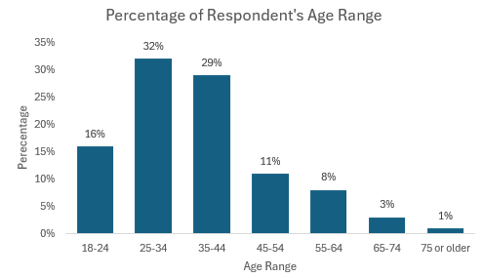

Gender
Respondents were asked to indicate their gender in our survey. As shown in Figure 2.0 below, 64% of respondents identified as female and 35% as male. Additionally, 1% of respondents selected the "Other" option, recognizing identities beyond the traditional male and female categories. This inclusive approach ensured that all individuals had the opportunity to accurately represent their gender identity.
Since gender was asked as a nominal question, the most appropriate measure of central tendency is the mode, which was 2 in this dataset. Given that responses were coded as 1 for male, 2 for female, and 3 for other, this means that female respondents were the most frequent in the sample. The standard deviation of 0.497 provides insight into the variability of responses. Since a lower standard deviation indicates less dispersion, this suggests that most responses were clustered around one category, which was identified as female.
Figure 2.0
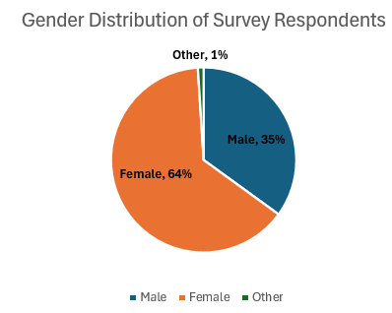

Marital Status
We asked respondents to indicate their marital status offering three options "single" "married" and "other" (e.g. divorced widowed etc.), which were coded in our SPSS output as 1, 2, and 3, respectively. These categories allowed participants to select the response that best reflected their current situation. We included this question because we believe there may be differences in purchase behaviors between single and married individuals making this information valuable for our analysis.
Many respondents were single making up 49% of the sample. Since marital status was asked a nominal question, the most appropriate measure of central tendency is the mode which was 1. Therefore, this confirms the fact that “single” was the largest group. The standard deviation of 0.637 indicates some variability in responses but because this value is relatively low it suggests that most answers clustered around one primary category rather than being evenly distributed among all three options.
Figure 3.0
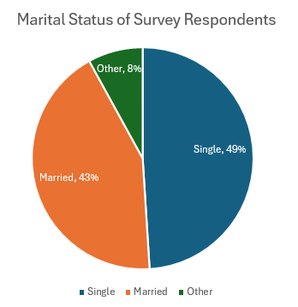

Income
We asked respondents to provide their approximate before-tax household income in dollars. To better analyze the data, we grouped their responses into five income brackets. The first category includes individuals earning less than $50,000, which represents lower-income households. The second range, $50,000 – $99,999, captures middle-income earners. The third bracket, $100,000 – $149,999, accounts for upper-middle-income respondents. The fourth category, $150,000 – $199,999, reflects higher-income households, while the final range, $200,000 or more, represents the highest income group in our survey. These classifications allow for meaningful comparisons across different financial backgrounds and help identify potential trends in spending habits based on income levels.
Since income was asked as a ratio-level question, we were able to calculate the mean, which is the strongest measure of central tendency. The average before-tax household income among respondents was approximately $96,446.99. However, the standard deviation of $248,039.31 indicates significant variation in household income levels. This high standard deviation suggests a wide range of earnings among respondents, with some households earning substantially more or less than the average. Additionally, the median income of $62,500 reflects the midpoint of the dataset, meaning half of the respondents earn below this amount while the other half earn more. The fact that the median is lower than the mean suggests that a portion of high-income respondents is pulling the average up.

Figure 4.0
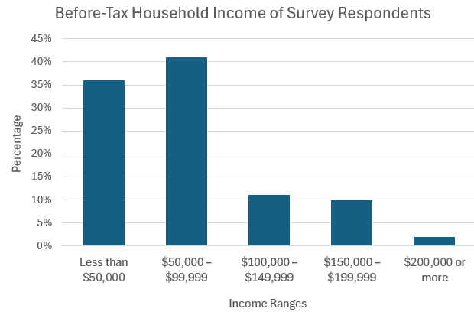

Open-Ended Question
We included an open-ended question in our survey asking respondents, “In one word what comes to mind when you think of CAVA?”. This allowed us to gauge participants’ sentiment toward CAVA and gather associations with the brand. After collecting responses, we classified them into three categories 0 = “irrelevant”, 1 = “negative”, and 2 = “positive.” The mode of the responses was 2 meaning that the most frequently occurring sentiment was positive with 64 percent of respondents expressing favorable impressions of CAVA.
The standard deviation was approximately 0.95658, indicating how much individual responses varied from the overall trend. A lower standard deviation would suggest that most respondents shared similar sentiments while a higher standard deviation would indicate a broader range of opinions. In this case, since the value is relatively close to 1 it suggests that while the majority of responses were positive there was still some variability in sentiment among respondents.
Examples of words respondents used to describe CAVA include "amazing", "fresh", and "healthy." These responses highlight the brand’s strong association with freshness and health which are key attributes that align with CAVA’s marketing strategy and brand positioning. The overwhelmingly positive sentiment suggests that customers view CAVA favorably particularly in terms of the quality and nutritional benefits of its offerings.
Figure 5.0
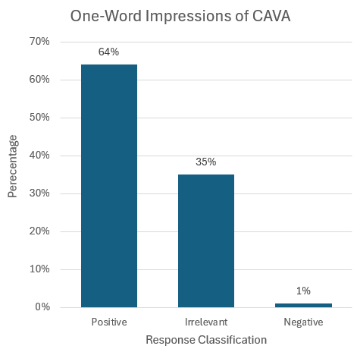

Descriptive Results
Descriptive tests serve as the foundation for understanding the basic characteristics of survey data, providing essential summaries of the sample's responses. Rather than focusing on comparisons or relationships between variables, descriptive tests focus on illustrating patterns, central tendencies, and the spread of data within a single variable or across multiple variables independently. Common outputs include measures such as the mean (average), median, mode, standard deviation, and range, all of which help to paint a clear picture of the overall data landscape.
These insights are crucial because they establish context before diving into deeper analyses. By understanding typical response patterns, marketers can better interpret subsequent difference or associative test results. While descriptive tests do not determine significance levels like p-values, they lay the groundwork for identifying areas of interest where further inferential testing may be beneficial. Ultimately, descriptive tests help marketers understand who their respondents are and how they generally think or behave, providing a strong starting point for more advanced statistical exploration.
Objective 1: To measure the physical expansion of the company through the analyzation of the store layout.
1.1 – Descriptive Statistics Test
We conducted a descriptive analysis test in order to measure the average amount of time customers spend in CAVA from entry to checkout (in minutes). The bar chart below shows the frequency distribution in time intervals ranging in minutes from zero to fifty. Based on the results displayed in the bar chart, the most frequent response (22%) for the amount of time spent in the store from entry to checkout was 10 minutes. The second most frequent response was fifteen minutes (15%). These findings inform us that customers are spending on average around 10-15 minutes in the fast-casual restaurant which could imply that they are spending their time either waiting in line or ordering/receiving food instead of dining in and reaching other key areas of the store. With little respondents reporting that they spend more than 35 minutes in the store, CAVA’s identity of being a fast-casual dining experience is maintained.
Figure 1.1
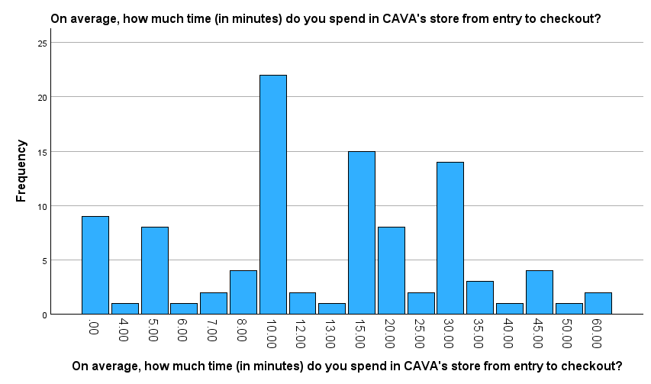
Objective 2: To measure customer experience and satisfaction across various fast-casual competitors to determine where CAVA is in consumers’ consideration set.
2.1 – Descriptive Statistics Test
We conducted a descriptive analysis to examine how often individuals dine at fast-casual restaurants each week. The chart below presents the frequency distribution (a measure of dispersion/variability) of dining occurrences per week, offering a visual overview of the patterns observed in the dataset.

Figure 2.1
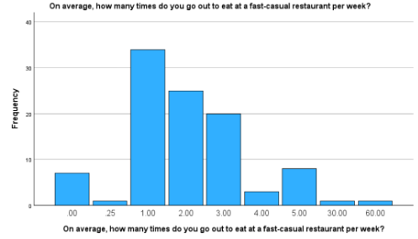
Based on the data, it can be inferred that the majority of people (34%) dine at fast-casual restaurants once per week. This trend suggests that once-weekly visits represent a common behavior among consumers, possibly driven by lifestyle routines, budget considerations, or preferences for occasional indulgence in fast-casual dining. This insight serves as a foundational understanding of dining frequency, which can be valuable for tailoring marketing strategies or operational planning in the fast-casual industry.
Objective 3: To identify legal threats that could impact consumer perceptions and prevent them from using the company’s products.
3.1 – Descriptive Statistics Test
We conducted a descriptive analysis to examine how often individuals dine at fast-casual restaurants each week. The chart below presents the frequency distribution (a measure of dispersion/variability) of if legal concerns would affect customers perceptions of CAVA.

Figure 3.1
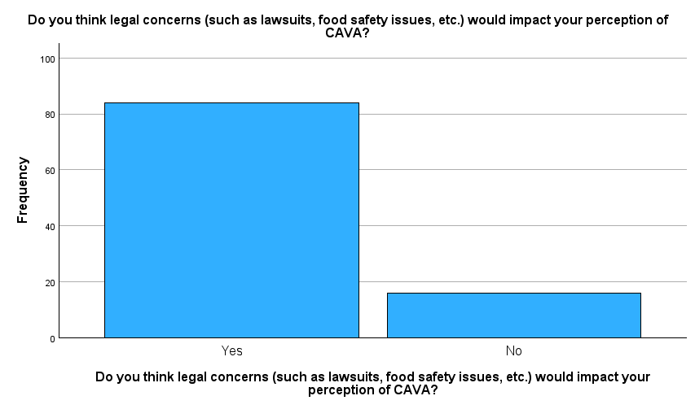
Based on this data, it can be inferred that a majority of people (84%) think that legal concerns such as lawsuits and food safety issues, would impact their perception of Cava. This trend suggests that legal threats represent a common concern among customers, which could be due to the fact that customers often times associate legal issues with potential health code violations or labor issues, which tarnishes restaurants reputations, such as Cava. This insight serves as a foundation for understanding the impact of legal concerns on those who frequently dine at fast-casual restaurants.
Objective 5: To assess consumer perceptions of CAVA’s pricing strategies in the context of current economic conditions to optimize future pricing and marketing strategies.
5.1 – Descriptive Statistics Test
A descriptive test was conducted to determine how much customers are willing to spend on one meal at CAVA. Responses varied in dollar amounts ranging from $4 to $80. The data reveals a clear concentration in the $15–$20 range, where $20 stands out as the most frequent choice, followed closely by $15. Outside of this core range, responses become more scattered, with smaller clusters around $25 and occasional outliers at higher prices like $40 or above. However, these higher spending preferences are far less common, highlighting that while there is some willingness to pay premium prices, a majority of respondents (19%) expect an affordable and accessible price point closer to $20 per meal.
Figure 5.1
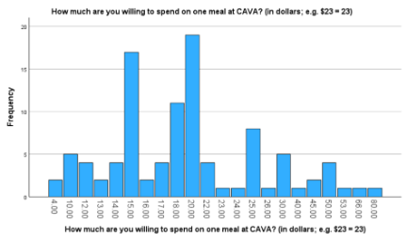
Objective 6: To analyze and identify CAVA’s major consumer segments by examining their attitudinal characteristics.
6.1 – Descriptive Statistics Test
We conducted a descriptive analysis to explore the primary factors influencing consumers’ decisions to dine at CAVA. The bar chart below displays the frequency distribution of participants’ most valued attributes when choosing to eat at CAVA, offering insight into consumer preferences.
Figure 6.1
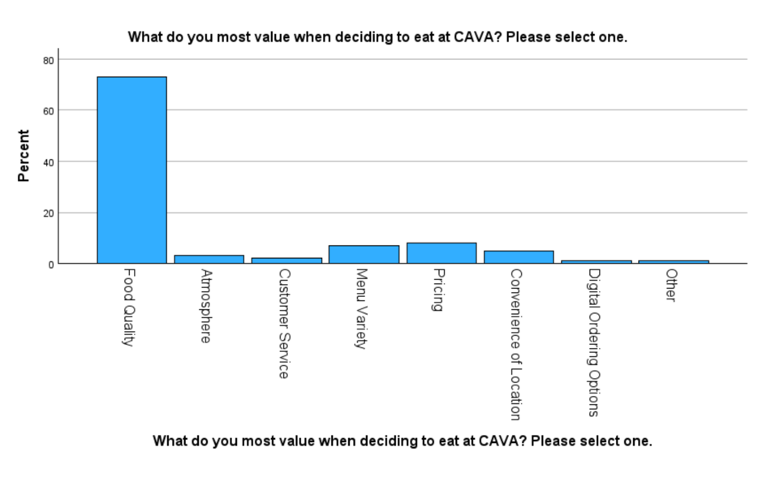
Based on the data, food quality was overwhelmingly the most important factor, selected by approximately 73% of respondents, suggesting that freshness, taste, and overall quality are central to CAVA’s appeal. Other factors, such as menu variety, pricing, and convenience of location, were selected far less frequently, each by under 10% of respondents. Attributes like atmosphere, customer service, and digital ordering options were valued by only a small portion of participants. This distribution highlights the dominant role food quality plays in the decision-making process, which can inform future marketing strategies and operational focus by emphasizing product excellence to attract and retain customers.

Difference and Associative Results
Difference analyses are conducted to compare two groups identified in a questionnaire, based on their survey responses, to determine whether any observed differences are statistically significant. For a difference to be considered significant, the p-value must be less than or equal to 0.05. Evaluating the significance of the p-value is essential; if it is not significant, the data will not yield meaningful results. Conversely, a significant p-value can provide valuable insights for understanding the broader population.
Associative tests, on the other hand, offer key insights for developing marketing strategies and tactics. These tests are designed to determine whether a stable relationship exists between two variables, whereas difference tests assess whether relationships differ between groups. Associative tests help identify correlations between variables, which is critical for creating effective marketing tactics. Like difference tests, a p-value of 0.05 or less indicates statistical significance. Additionally, associative tests include the correlation coefficient, a measure that indicates the strength of the relationship: values closer to one signify a strong association, while values near zero indicate no correlation. The sign also indicates the type of relationship; positive values indicate a direct relationship, while negative values suggest an inverse relationship.
Objective 1: To measure the physical expansion of the company through the analyzation of the store layout.
1.2 - Independent Samples T-Test
An independent samples t-test was conducted to examine whether there is a significant difference in the ease of navigating CAVA’s store layout and whether or not respondents have a CAVA location nearby. The test revealed that there was a statistically significant difference between the two groups. With the p-value (p=.006), we are able to determine that respondents that have a CAVA location nearby reported a higher mean value of 5.70 compared to those who do not have a CAVA located nearby, who had a mean value of 4.91.
Based on our 1-7 scale with 1 being strongly disagree and 7 being strongly agree, we are able to conclude that the higher mean value of 5.70 explains that those with a CAVA store located near them find the layout of the fast-casual restaurant easier to navigate than those that do not. The mean difference of 0.789 suggests that by having consistent access to the store and familiarity of the store layout influences the consumers perception of layout ease.
The findings from this test indicate that proximity to a CAVA location contributes to a more positive and favorable customer experience. This implies that proximity, increased exposure, and easy accessibility lead to a consumer’s ability to better navigate the fast-casual restaurant with ease.
Figure 1.2
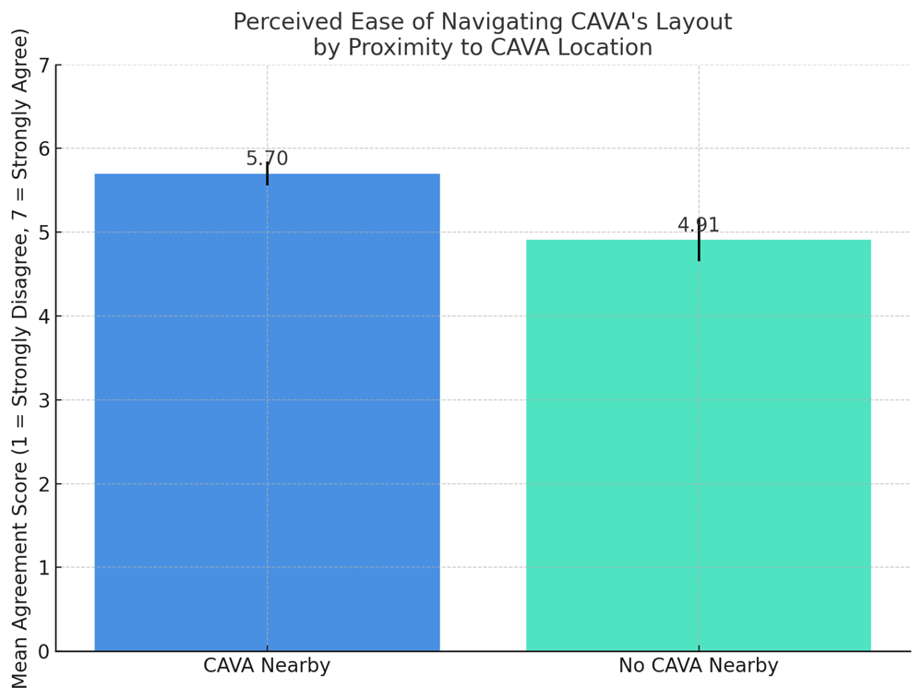
*Based on ranking on a 1-7 scale, 1 = strongly disagree to 7= strongly agree
1.3 - Crosstabs Test
A crosstabs test was conducted to determine whether respondent’s ranking of CAVA’s store layout differed from Chipotle’s, both being popular fast-casual restaurants. The ranking was based on a scale with 1 being the best and 5 being the worst. The results of this test disclosed that the Pearson Chi-Square value was <.001, which proves that there was a statistically significant relationship between the ranking of the two fast-casual restaurants. These results indicate that significant number of respondents found CAVA to have a better store layout and Chipotle to have a less favorable store layout. This positions CAVA to have a competitive advantage over Chipotle based on customer perception of store layout.
Figure 1.3
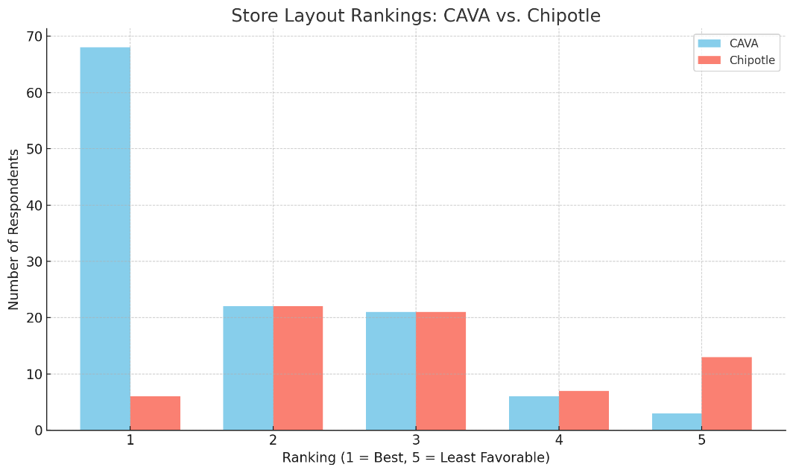
*Based on ranking on a 1-5 scale, 1 = best to 5 = worst
1.4 – Paired Samples T-Test
A paired samples t-test was conducted to evaluate the relationship between the average time spent in CAVA from entry to checkout and the number of different areas of the store visited. There was a strong positive correlation found between these two variables with the mean difference being 14.70. This suggests that those who reported spending more time (in minutes) in CAVA’s store typically visit more key areas of the store. This test proves that there is a statistically significant difference between the two variables because (p < .001).
Figure 1.4
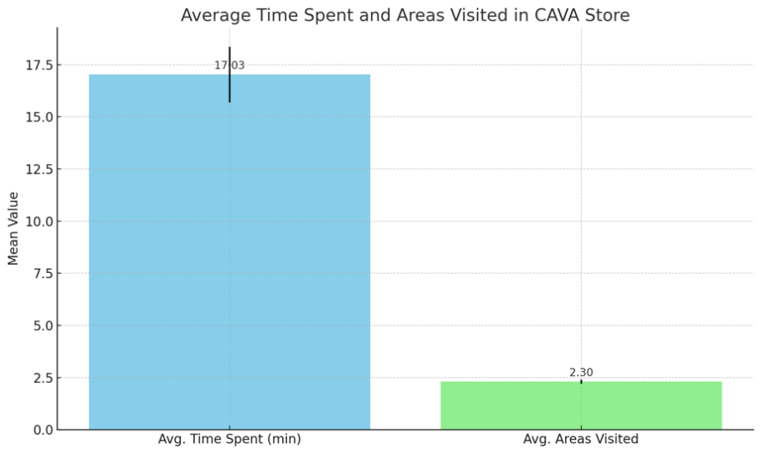

Objective 2: To measure customer experience and satisfaction across various fast-casual competitors to determine where CAVA is in consumers’ consideration set.
2.2 – Independent Samples T-Test
A difference analysis was conducted to explore potential differences between people’s satisfaction with CAVA’s food quality and their rankings of the restaurant compared to other fast-casual establishments. A significant difference (p < .001) was observed between groups that ranked CAVA as 1 (top) or 5 (bottom) in relation to their satisfaction with CAVA’s food quality. This finding indicates a notable difference in the means of the two groups: individuals who are more satisfied with CAVA’s food quality tend to rank the restaurant higher. Conversely, it can be inferred that customers who rank CAVA lower have a less favorable perception of its food quality.
Figure 2.2
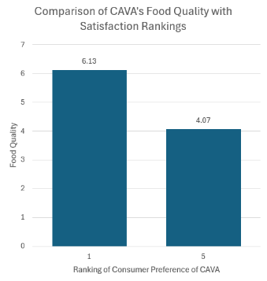
*For food quality (y-axis), it is on a scale of 1 (Extremely Dissatisfied) to 7 (Extremely Satisfied).
*For ranking (x-axis), participants ranked the fast-casual restaurant they like the most as a 1 (top) and the fast-casual restaurant they like the least a = 5 (bottom).
2.3 – Crosstabs Test
We conducted a crosstabs test, an associative analysis, to examine the relationship between having eaten at CAVA and its ranking compared to other fast-casual competitors. The SPSS output illustrates that individuals who have dined at CAVA ranked it higher than those who haven't. This relationship is a statistically significant association (p < 0.001), with 38.3% of CAVA diners ranking it as their top choice, compared to only 5.3% of non-diners.
Figure 2.3
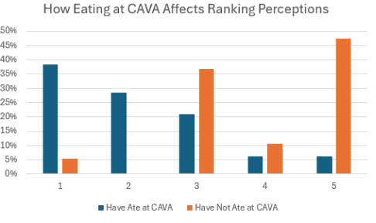
*Based on ranking on a 1-5 scale, 1 = most liked to 5 = least liked.
2.4 – Correlations Test
An additional associative test that we conducted was a correlations test to determine whether there is an association between age and how many restaurants consumers consider and to determine the strength of the potential association. As seen in the correlations SPSS output, the results were statistically significant (p = 0.036), meaning that there is a weak, negative association between the two variables (R² = -0.210). This means that as people age, they typically consider less restaurants.
Table 2.4
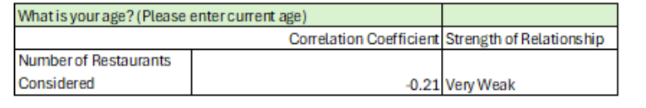
Objective 3: To identify legal threats that could impact consumer perceptions and prevent them from using the company’s products.
3.2 – Crosstabs
A crosstabs test was conducted to assess whether marital status influences how customers rank the legal threat of false advertising when choosing to eat at CAVA. The test result was not statistically significant (p = 0.781), indicating no meaningful relationship between these factors. From a managerial perspective, this suggests that concerns about false advertising are perceived similarly across customer segments, regardless of marital status. Therefore, marketing or risk communication strategies addressing this issue do not need to be segmented by marital status.
Figure 3.2
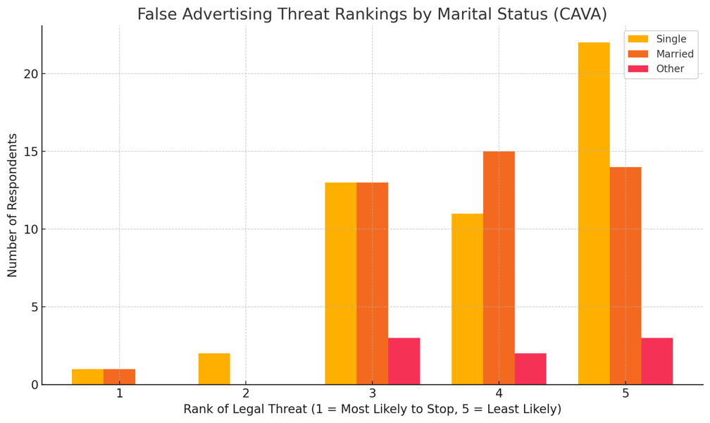
*Based on ranking on a 1-5 scale, 1 = Most likely to stop to 5 = Least likely to stop.

3.3 – Correlations
An additional associative test that we conducted was a correlations test to determine whether there is an association between the approximate before-tax household income, and “what percentage of people of people do you believe consider not purchasing from CAVA due to legal issues.” In the SPSS output, the results were statistically significant, (p = 0.020) and there was a very weak, yet positive strength of the relationship (R²= 0.232). This means that as household income increases, there is a slight tendency for people to believe that more individuals would consider not purchasing from CAVA due to legal issues.
Table 3.3
What percentage of people do you believe consider not purchasing from CAVA due to legal issues? | Correlation Coefficient | Strength of Relationship
What is your approximate before-tax household income? | 0.232 | Very Weak, Positive

3.4 – Independent Samples T-Test
An independent samples t-test was conducted to examine whether the impact of legal threat on customer’s likelihood to purchase from CAVA was affected by marital status. The test did not reveal a statistically significant difference between the two groups (p = 0.111). Since the p-value is greater than 0.05, we conclude that the difference in perceived value between the groups is not significant.
Specifically, respondents who feel that legal threats would impact their likelihood to purchase from CAVA that are married (Mean = 5.44) had a higher value compared to those that are single (Mean = 5.02). The mean difference of -0.42 suggests that the perception of legal threats influences a customer’s likelihood to purchase from CAVA. What this means is that CAVA is more likely to see less business from married couples compared to those that are single, based on if there are legal threats associated with CAVA.
Figure 3.4
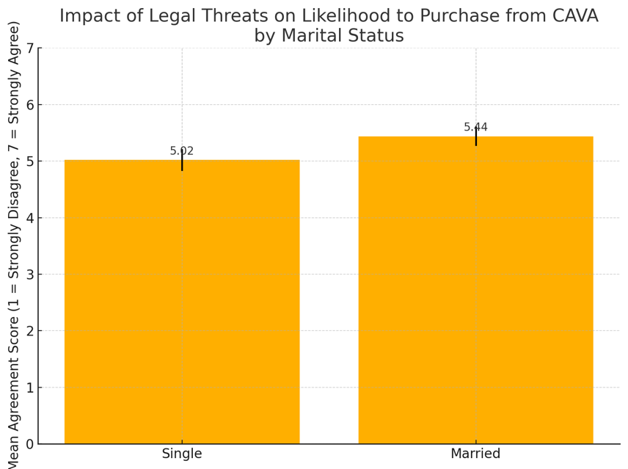
*Based on a 1-7 scale, 1 = Strongly Disagree to 7 = Strongly Agree

Objective 5: To assess consumer perceptions of CAVA’s pricing strategies in the context of current economic conditions to optimize future pricing and marketing strategies
5.2 – Independent Samples T-Test
An independent samples t-test was conducted to examine whether perceptions of CAVA’s value, compared to competitors, differ between those who believe the overall value at restaurants has decreased versus those who believe it has increased, due to recent economic conditions. The test revealed a statistically significant difference between the two groups (p = 0.017). Since the p-value is less than 0.05, we conclude that the difference in perceived value between the groups is significant.
Specifically, respondents who feel that overall value at restaurants has increased rated CAVA's value higher (Mean = 5.22) than those who feel that overall value has decreased (Mean = 4.39). The mean difference of -0.823 suggests that perceptions of general economic value influence how favorably consumers view CAVA’s pricing compared to its competitors. Practically, this implies that CAVA is perceived as delivering better value by consumers who see improvement in economic value at restaurants, reinforcing the importance of economic sentiment in pricing perception.
**It is important to note that 39 responses indicating "overall value has not changed" were excluded from this analysis to focus on the polarized viewpoints of value increase and decrease.**
Figure 5.2
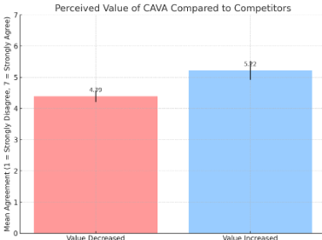
*Based on a 1-7 scale, 1 = Strongly Disagree to 7 = Strongly Agree

5.3 – Paired Samples T-Test
A paired samples t-test was conducted to determine whether there is a statistically significant difference between how much respondents are willing to spend on one meal at CAVA compared to the average price they typically pay at other fast-casual restaurants. This analysis helps determine if consumers perceive CAVA's pricing in line with or different from their usual fast-casual dining habits. The test revealed a statistically insignificant difference between the two groups (p = 0.420). Since the p-value is greater than 0.05, we conclude that the difference in perceived value between the groups is insignificant.
This suggests that, on average, respondents are willing to spend a similar amount at CAVA as they do at comparable fast-casual establishments. These findings imply that CAVA is competitively priced within its category, and price does not appear to be a distinguishing factor driving consumer preference or deterrence in this context.
Figure 5.3
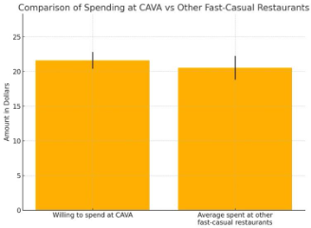
5.4 – Correlations Test
A correlations test was conducted to examine the relationship between the amount respondents are willing to spend on a meal at CAVA and their perception of CAVA's pricing value compared to competitors. The goal was to determine whether perceived value influences spending intentions at the restaurant.
The results revealed a positive and statistically significant correlation between the two variables, with a Pearson correlation coefficient (R² = 0.252) and a significance level of (p = 0.011). While the correlation is “very weak” given that it falls in the 0.21 to 0.4 range of correlation, it indicates that as perceptions of CAVA offering better value for money increase, respondents are also willing to spend slightly more on a meal at the restaurant. This finding suggests that enhancing customer perceptions of value could have a positive impact on willingness to spend at CAVA.
Table 5.4
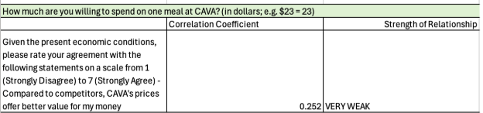
*Based on a 1-7 scale, 1 = Strongly Disagree to 7 = Strongly Agree

Objective 6: To analyze and identify CAVA’s major consumer segments by examining their attitudinal characteristics.

6.2 – Paired Samples T-Test
A paired samples t-test was conducted to compare the number of times customers visited CAVA to the number of CAVA-related social media posts or ads they noticed in the past month. The mean number of visits was 2.47, while the mean number of noticed social media posts or ads was 1.74. The test revealed a statistically significant difference between these two means (p=0.015). This suggests that customers are visiting CAVA significantly more often than they are noticing related social media content. From a managerial perspective, this points to an opportunity to better align CAVA’s digital marketing reach with actual customer behavior. Enhancing social media presence could help reinforce existing customer habits and potentially drive even more visits.
Figure 6.2
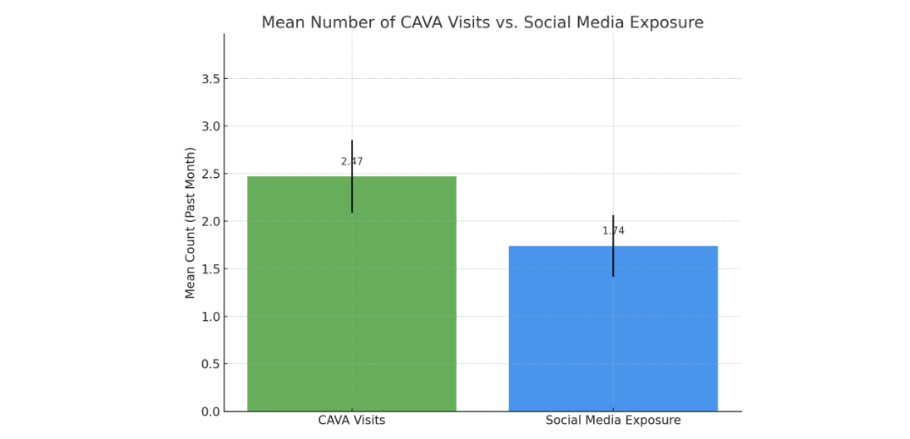

6.3 – Correlations
A correlations test was conducted to assess the relationship between participants' age and the number of times they visited CAVA in the past month. The analysis revealed a statistically significant, negative correlation between age and CAVA visits, (R² = -0.205; p = 0.040). This indicates that there is a slight tendency for younger individuals to visit CAVA more frequently than older individuals. Although the strength of the correlation is “very weak,” the relationship is significant at the 0.05 level, suggesting that age may be a modest but meaningful factor in predicting consumer behavior related to CAVA.
The negative direction of the correlation implies that as age increases, the number of CAVA visits tends to decrease. This could reflect generational differences in dining preferences, brand awareness, or lifestyle habits. For example, younger individuals may be more drawn to CAVA’s modern branding, fast-casual dining format, or health-conscious menu options, which are often more heavily marketed toward younger demographics. Older adults, on the other hand, may have more established eating habits or prefer alternative dining environments.
Table 6.3
How many times have you visited CAVA in the past month? | Correlation Coefficient | Strength of Relationship
What is your age? (Please enter current age) | –0.205 | Very Weak
6.4 – Crosstabs
A crosstabulation was conducted to examine the relationship between gender and what individuals most value when deciding to eat at CAVA. Across all gender groups, “Food Quality” was the most valued factor, especially among females (43%) and males (29%). This was followed by “Pricing,” noted by 6 females and 2 males, and “Menu Variety,” which was selected by 6 females and 1 male. Other factors, including “Atmosphere”, “Customer Service”, and “Convenience of Location”, received relatively fewer selections. Notably, “Digital Ordering Options” was valued by only 1 male respondent, while Other was chosen by only 1 female respondent. These results suggest that food quality is the dominant factor influencing dining decisions at CAVA, with minor variations in secondary preferences across gender groups.
Figure 6.4
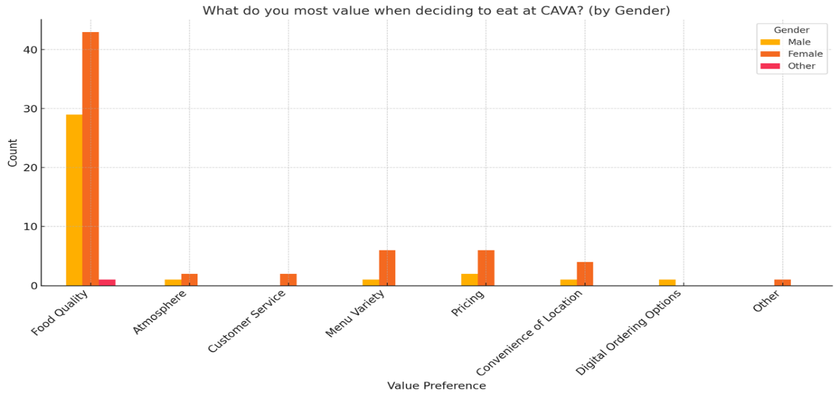

LIMITATIONS
Looking back at our research process, there are several areas we could have improved during the design and development of our survey. One of the most consistent issues across team members was the specificity and alignment of survey questions with their objectives. Several team members expressed that their questions were either too broad or lacked the depth needed to provide actionable insights. For example, more detailed questions on store layout features (like ordering stations or ambiance) could have given CAVA clearer direction for physical expansion. Similarly, in the legal threats section, grouping diverse issues under one umbrella limited the ability to assess which risks most influenced perception.
Another area that could have been improved was survey structure and response logic. Some questions assumed prior experience with CAVA, which led to responses from participants who lacked the context to answer meaningfully. Implementing early screeners or skip logic based on familiarity would have strengthened data quality. Open-ended and ratio questions also presented issues with extreme or inconsistent inputs, which could have been avoided by using sliders, drop-down ranges, or validation constraints to ensure more realistic responses.
Group coordination also presented challenges. Despite efforts to collaborate and review each other’s work, there were overlaps and redundancies, especially in questions about pricing and quality, highlighting the need for stronger internal communication and clearer role definitions early on. Some questions ended up duplicating others, and a few were revised last-minute as a result. A shared template or more detailed pre-survey discussion might have streamlined our approach and ensured each section contributed uniquely to the overall analysis.
On the data analysis side, segmentation and statistical depth could have gone further. While demographic variables like age and gender were considered in isolation, combining these with attitudinal or behavioral factors, such as motivations for visiting CAVA or value perceptions, would have yielded richer consumer insights.
Lastly, several of us realized in hindsight that we could have designed our questions with the analysis in mind. Some items didn’t translate well into the tests we hoped to run or didn’t yield useful output. In some cases, tests like correlation and crosstabs were statistically significant but weak in strength. Although sometimes uncontrollable, had we curated a more complementary set of survey questions could have resulted in more actionable findings from these specific types of tests. Thinking through the end-use of our data during the survey creation stage could have made the analysis more cohesive and meaningful. Despite these challenges, we adapted and learned throughout the process, gaining valuable insight into how to conduct and improve real-world marketing research.

CONCLUSIONS AND MANAGERIAL RECOMMENDATIONS
Objective 1: To measure the physical expansion of the company through the analyzation of the store layout.
Conclusion: For objective 1, we examined how customers perceive the store layout of CAVA and how they compared it to competitors to help measure CAVA’s future expansion and provide feedback on how they can improve. By conducting an independent samples t-test we were able to conclude whether there is a significant difference in the ease of navigating CAVA’s store layout and respondents having a location near them. This test revealed a significant difference and concluded that having a CAVA location nearby leads to a more favorable and positive customer experience. By conducting a crosstabs test, we were aiming to find out whether respondents ranking of CAVA’s store layout differed from Chipotles. This test assured us that there was as statistically significant relationship between the ranking of the two restaurants. CAVA was perceived to have a better store layout then Chipotle. Lastly, we conducted a paired samples t-test to examine the relationship between the average time spent in CAVA from entry to checkout and the number of different areas of the store visited. These results demonstrated a statistical significance with a strong positive correlation between the two.
Recommendations: Based on the results from our research, we were able to create a few recommendations for CAVA to consider in order to enhance their store layout when physically expanding the company. To start off, CAVA should prioritize expanding its physical presence by opening new restaurants in areas where the brand has limited accessibility. This recommendation would be beneficial to implement because our research shows how customers with previous familiarity and AVA store exposure have a more pleasurable experience at CAVA. Another recommendation would be to highlight CAVA’s store layout ranking as being higher than Chipotle as a competitive advantage. This could drive more customers to visit and experience CAVA’s store layout. By implementing these recommendations when expanding their locations, CAVA would enhance their store layout to create a more favorable experience for consumers. This would increase customer retention and revenue for the company.
Objective 2: To measure customer satisfaction across various fast-casual competitors to determine where CAVA is in consumers’ consideration set.
Conclusion: For objective 2, we examined customer experience and satisfaction with CAVA compared to its fast-casual competitors to understand CAVA’s position in consumers’ consideration set. The Independent T-test that we ran revealed a significant difference between satisfaction with CAVA’s food quality and its ranking compared to other fast-casual restaurants. People who rated CAVA highly for food quality also ranked it higher overall compared to competitors. Similarly, the Crosstabs Test shows that individuals who have dined at CAVA rank it significantly higher than those who have not emphasizing the importance of brand familiarity and customer experience in shaping consumer preferences. The people who have not eaten at CAVA may have varying reasons, so this could be investigated further. Additionally, the Correlations Test we conducted indicated a weak but statistically significant negative association between age and the number of restaurant consumers considering that younger individuals are more open to exploring new dining options. In contrast, older consumers tend to have established preferences.
Recommendation: Based on the insights from our research, we came up with several recommendations for CAVA to consider increasing customer satisfaction and encourage customers to consider choosing CAVA more when dining at fast-casual restaurants. To strengthen customer satisfaction and loyalty CAVA should prioritize maintaining high food quality standards and offer more rewards. CAVA should utilize customer feedback and try to ensure consistency and improvement in its offerings. Increasing brand awareness and driving trial among non-diners through targeted marketing campaigns such as first-time diner promotions or digital ads can help expand CAVA’s customer base. Additionally, marketing strategies should be tailored to different age demographics using social media engagement and digital loyalty programs for younger consumers while emphasizing quality convenience and consistency for older consumers. Finally, competitive positioning should highlight key differentiators such as ingredient quality health-conscious offerings, and sustainability efforts to reinforce CAVA as a leading choice in the fast-casual market. These integrated strategies will collectively enhance CAVA’s brand perception, customer experience, and overall competitive standing.
Objective 3: To identify legal threats that could impact consumer perceptions and prevent them from using the company’s products.
Conclusion: For objective 3, we identified legal threats that could impact consumer perceptions and precent them from using CAVA’s products. The correlations test that we ran which compared the approximate before-tax household income and the percentage of people that are believed to consider not purchasing from CAVA due to legal issues revealed a very weak, positive relationship of 0.232. This means that as household income increases, there is a slight tendency for people to believe that more individuals would consider not purchasing from CAVA due to legal issues. On the other hand, we also conducted a crosstabs test, an associative analysis, to examine the relationship between marital status and how large of legal threat false advertising is to customers. We conducted that there was no association when it comes to these two factors. This could be possibly due to the fact that marital status had no factor for people’s opinions on how large of a legal threat false advertising is to customers. Lastly, we conducted an independent samples T-test to determine whether marital status influenced how legal threats impact a customers’ likelihood to purchase from CAVA. The test did not reveal a statistically significant difference between the two groups (p = 0.0111). Since the p-value is greater than 0.05, we conclude that the difference in perceived value between the groups is not significant.
Recommendations: Based on our results from our research, we developed several approaches in order to identify legal threats that could impact consumer perceptions and potentially prevent them from using CAVA’s products. This included analyzing correlations between demographic factors as well as consumer attitudes, where we evaluated how different legal scenarios were perceived by consumers. What we recommend is that CAVA should take a proactive approach when it comes to managing legal threats, by utilizing strategies such as being completely transparent with their customers about their practices. This is included but not limited to food safety, advertising accuracy, and employee treatment. Because CAVA has dealt with these issues in the past, it is highly important for them to regularly monitor their customer satisfaction rates, as well as being able to quickly address any issues or complaints. By implementing clear communication strategies, CAVA will be able to eliminate or help reduce the likelihood of their reputation being damaged due to legal issues or threats.

Objective 5: To assess consumer perceptions of CAVA’s pricing strategies in the context of current economic conditions to optimize future pricing and marketing strategies
Conclusion: For Objective 5, we examined how broader economic perceptions and personal spending behavior influence consumer views of CAVA’s value proposition. The Independent Samples T-Test revealed a statistically significant difference (p = 0.017) in value perception between consumers who feel restaurant value has increased versus those who feel it has decreased due to economic changes. Those with a more positive outlook on value rated CAVA’s pricing more favorably (Mean = 5.22 vs. 4.39), suggesting that economic sentiment plays a meaningful role in shaping brand perception. The Paired Samples T-Test, however, found no significant difference (p = 0.420) between how much people are willing to spend at CAVA and what they typically pay at other fast-casual restaurants, indicating CAVA’s pricing aligns well with competitors and is unlikely to be a barrier. Finally, the Correlations Test showed a weak but statistically significant positive relationship (R² = 0.252, p = 0.011) between perceived value and willingness to spend, meaning customers who see greater value in CAVA are slightly more willing to spend on a meal. Together, these results emphasize the importance of perceived value and economic mindset in influencing consumer behavior toward CAVA.
Recommendations: Based on these findings, CAVA should focus on reinforcing the perception of strong value for price. This could involve spotlighting premium ingredients, freshness, and portion sizes in marketing messages to justify pricing and appeal to cost-conscious diners. Introducing limited-time offers or bundle deals could provide an immediate sense of savings without needing to lower core menu prices. For frequent diners, CAVA could introduce tiered loyalty rewards that increase benefits with spending frequency to retain high-value customers. Additionally, messaging around economic value can be tailored by segment: younger consumers may respond more to price-based promotions, while older demographics might value messaging around quality and consistency. Lastly, continuing to monitor consumer sentiment around affordability will be essential as economic conditions evolve, ensuring CAVA stays aligned with customer expectations and purchasing power.
Objective 6: To analyze and identify CAVA’s major consumer segments by examining their attitudinal characteristics.
Conclusion: For Objective 6, we explored the attitudinal characteristics of CAVA’s consumer base to identify its major customer segments. The Paired Samples T-Test revealed a significant discrepancy between the frequency of CAVA visits and the frequency of noticing CAVA-related social media content. Participants visited CAVA more often than they reported seeing CAVA content online, suggesting that digital exposure alone may not be the primary driver of customer visits. Additionally, the Correlation Test demonstrated a statistically significant but weak negative relationship between age and visit frequency, indicating that younger consumers are more likely to dine at CAVA. Finally, the Crosstabs analysis showed that food quality was the most valued factor in dining decisions across all genders, with some variation in secondary priorities such as pricing and menu variety. Together, these findings suggest that CAVA’s audience skews younger, values food quality, and may be influenced by factors outside of direct digital marketing, pointing to the need for a more nuanced understanding of what drives visitation.
Recommendations: Based on these insights, we recommend that CAVA develop segmented marketing strategies that align with the unique preferences of its core consumer groups. Since younger individuals are more likely to visit CAVA, the brand should strengthen engagement through social media platforms, influencer partnerships, and loyalty programs tailored to Gen Z and Millennials. However, because visitation is occurring more frequently than social media exposure, CAVA should also explore offline drivers such as word-of-mouth, location convenience, or experiential factors like in-store ambiance. To deepen engagement across segments, CAVA can implement attitudinal surveys or psychographic profiling in future research to better understand motivations beyond demographics. Lastly, reinforcing its commitment to food quality through transparent sourcing stories and sustainability messaging can help solidify its brand image across gender and age groups, ultimately strengthening customer loyalty and expanding its reach within the fast-casual market.

REFERENCES
“2022 State of the Restaurant Industry.” NRA, 31 Jan. 2022, restaurant.org/state-of-the-industry/.
“About Us.” CAVA, cava.com/ourstory. Accessed 12 Feb. 2025.
“Are the traffic gains at CAVA sustainable?" Nation's Restaurant News, 2023. https://www.nrn.com/food-trends/are-the-traffic-gains-at-cava-sustainable-
Aziz, Salman. “Chipotle vs. Competitors: How CMG Stands out in the Fast-Casual Dining Space.” Medium, 29 Aug. 2024, medium.com/@armourstocks.com/chipotle-vs-competitors-how-cmg-stands-out-in-the-fast-casual-dining-space-5ba58dd1e732.
"Cava's Recipe for Success? Acquiring Other Chains to Expand." The Wall Street Journal, 2022. https://www.wsj.com/video/series/the-economics-of/cavas-recipe-for-success-acquiring-other-chains-to-expand/13903BB4-7E87-4DB4-A3E7-392156E19C69
“Cava Group Reports Fourth Quarter and Full Year Fiscal 2023 Results.” Cava Group, Inc., 26 Feb. 2024, investor.cava.com/news/news-details/2024/CAVA-Group-Reports-Fourth-Quarter-and-Full-Year-Fiscal-2023-Results/default.aspx.
“Cava Group, Inc. - Cava Group Reports Third Quarter 2024 Results.” CAVA Group Reports Third Quarter 2024 Results, 12 Nov. 2024, investor.cava.com/news/news-details/2024/CAVA-Group-Reports-Third-Quarter-2024-Results/default.aspx.
“Customer Demographics and Target Market of Cava Group.” CANVAS, SWOT, PESTEL & BCG Matrix Editable Templates for Startups. 2 Oct. 2024. Web. 15 Feb. 2025. https://canvasbusinessmodel.com/blogs/target-market/cava-group-target-market
"Decoding Cava Group Inc (CAVA): A Strategic SWOT Insight." GuruFocus, 2023. https://www.gurufocus.com/news/2601937/decoding-cava-group-inc-cava-a-strategic-swot-insight
“Decoding Cava’s Success.” The Capital Letter, 12 Apr. 2024, www.capitalletter.com/p/decoding-cavas-success.
Fantozzi, Joanna. “The New Value Equation at Restaurants.” Nation’s Restaurant News, 4 Feb. 2025, www.nrn.com/quick-service/the-new-value-equation-at-restaurants.
"How Some Operators are Striving for Better Sustainability Standards." QSR Magazine, 2020. https://www.qsrmagazine.com/slideshow/how-some-operators-are-striving-better-sustainability-standards/
Klein, Danny. “Chipotle Invests in a Mediterranean Fast Casual Brand.” QSR Magazine, 30 Oct. 2024, www.qsrmagazine.com/story/chipotle-invests-in-a-mediterranean-fast-casual-brand/.
Maynard, Micheline. “Why 2025 May Continue to See Bankruptcies Throughout the Chain Restaurant Industry.” MSN, 29 Dec. 2024, www.msn.com/en-us/money/companies/why-2025-may-continue-to-see-bankruptcies-throughout-the-chain-restaurant-industry/ar-AA1wEa57.
Maze, Jonathan. “As Restaurants Head into 2025, More Economic Uncertainty Abounds.” Restaurant Business, Restaurant Business, 2 Jan. 2025, www.restaurantbusinessonline.com/financing/restaurants-head-2025-more-economic-uncertainty-abounds.
“Mediterranean Restaurant Chain Cava Lifts Annual Sales Growth Forecast, Shares Jump | Reuters.” Reuters. 12 Nov. 2024. Web. 16 Feb. 2025. https://www.reuters.com/business/retail-consumer/mediterranean-restaurant-chain-cava-lifts-annual-sales-growth-forecast-shares-2024-11-12/
Mintz. (n.d.-a). Villa v. Cava Mezze Grill. https://www.mintz.com/industries-practices/case-studies/villa-v-cava-mezze-grill
Morine, Nicholas. “Cava Bucks Restaurant Industry Blues, Showing Double-Digit Growth.” RetailWire. 13 Nov. 2024. Web. 15 Feb. 2025. https://retailwire.com/cava-restaurant-industry-showing-growth/
Nath, Trevir. “Fast-Casual vs. Fast-Food: What’s the Difference?” Investopedia, Investopedia, www.investopedia.com/articles/investing/020515/fast-food-versus-fast-casual.asp. Accessed 12 Feb. 2025.
Roumeliotis, Greg, and Harry Brumpton. “Cava to Acquire Zoe’s Kitchen for $300 Million” | Reuters.” Reuters, 17 Aug. 2018, www.reuters.com/article/world/americas/cava-to-acquire-zoes-kitchen-for-300-million-idUSKBN1L217U/.
Sheridan, Nina. “What Are the Main Competitors of Cava in the Mediterranean Fast-Casual Sector?” Latterly.Org, www.latterly.org/cava-competitors/. Accessed 12 Feb. 2025.
Toxin Free USA, GMO. F. (2023, October 23). Toxin free USA sues cava for food containing pesticides and food packaging containing pfas. PR Newswire: press release distribution, targeting, monitoring and marketing. https://www.prnewswire.com/news-releases/toxin-free-usa-sues-cava-for-food-containing-pesticides-and-food-packaging-containing-pfas-301963353.html

APPENDIX

Qualtrics Survey
CAVA Research Project

Start of Block: Introduction

Intro This study is being conducted by a group of marketing research students at Florida State University. The study's objective is to collect information regarding fast-casual consumer preferences when deciding where to eat. Your participating in this study is completely anonymous, carries no foreseeable risk, and is strictly voluntary. If you choose to participate, you have the right to withdraw from the study at any time. Please read the questions carefully and as truthfully as possible. Thank you for your help!

End of Block: Introduction

Start of Block: Objective 1 "Sales Trends" - Ashley

Ashley_Nominal_1 Is there a CAVA located near you?
- Yes
- No
- Unsure

Ashley_Ordinal_1 Please rank the following fast-casual restaurants based on their store layout, with 1 (top) being the best and 5 (bottom) being the least favorable.
______ Cava
______ Chipotle
______ Surcheros
______ Sweetgreen
______ Blaze Pizza

Ashley_Interval_1 Please indicate the extent to which you agree with the following statements, with 1 (Strongly Disagree) and 7 (Strongly Agree).
 | Strongly disagree |  |  | Neither agree nor disagree |  |  | Strongly agree
CAVA's overall layout is easy to navigate
CAVA's store layout enhanced my overall experience
CAVA's key areas (e.g. food stations, seating areas, etc) are clearly marked

Ashley_Ratio_1 On average, how much time (in minutes) do you spend in CAVA's store from entry to checkout?
________________________________________________________________

Ashley_Ratio_2 How many different areas of the store (e.g., food station, seating areas, bathrooms, etc.) do you usually visit during your time at CAVA?
________________________________________________________________

End of Block: Objective 1 "Sales Trends" - Ashley

Start of Block: Objective 2 "Customer Satisfaction/Competitors" - Jacqulyn

Jacqulyn_Nominal_1 Have you ever eaten at CAVA?
- Yes
- No

Jacqulyn_Ordinal_1 Please rank the fast-casual restaurants on the following list according to your degree of liking for each, assigning the fast-casual restaurant you like the most a rank = 1 (top) and the fast-casual restaurant you like the least a = 5 (bottom).
______ Chipotle
______ Panera Bread
______ QDOBA Mexican Eats
______ Sweetgreen
______ CAVA

Jacqulyn_Interval_1 Please indicate how satisfied, on a scale of 1 (Extremely Dissatisfied) to 7 (Extremely Satisfied), with each of the following:
 | Extremely Dissatisfied |  |  | Neither Dissatisfied or Satisfied |  |  | Extremely Satisfied
CAVA's food quality
CAVA's customer service
CAVA's dining atmosphere

Jacqulyn_Ratio_1 On average, how many times do you go out to eat at a fast-casual restaurant per week?
________________________________________________________________

Jacqulyn_Ratio_2 On average, how many restaurants do you consider before making a purchase for fast-casual food? (Enter a number: ___)
________________________________________________________________

AC Please select the color that starts with the letter "R".
- Blue
- Green
- Orange
- Red
- Purple

End of Block: Objective 2 "Customer Satisfaction/Competitors" - Jacqulyn

Start of Block: Objective 3 "Legal Considerations" - Luke S

LukeS_Nominal_1 Do you think legal concerns (such as lawsuits, food safety issues, etc.) would impact your perception of CAVA?
- Yes
- No

LukeS_Interval_1 Please respond to the following statements by indicating your level of agreement on a scale of 1 (Strongly Disagree) to 7 (Strongly Agree):
 | Strongly disagree |  |  | Neither agree nor disagree |  |  | Strongly agree
Legal threats related to CAVA would affect my likelihood to continue purchasing their products.
Legal issues would affect my decision to recommend CAVA to others.

LukeS_Ratio_1 What percentage of people do you believe consider not purchasing from CAVA due to legal issues? (Enter the number without the % symbol: ___)
________________________________________________________________

LukeS_Ordinal_1 Please rank the following legal threats according to their likelihood of stopping you from choosing to eat at CAVA, assigning the legal threat you find most likely to stop you a rank of 1 (top) and the legal threat you find least likely to stop you a rank of 5 (bottom).
______ Health and Safety Regulations
______ Food Safety Regulations
______ Employment Law Issues
______ Breach of Contracts
______ False Advertising

LukeS_Ratio_2 How much time (in months) would pass before you would feel comfortable dining at CAVA again after a legal issue related to its food practices?
________________________________________________________________

End of Block: Objective 3 "Legal Considerations" - Luke S

Start of Block: Objective 4 "Social-Cultural Trends" - Luke C

LukeC_Nominal_1 Which of the following socio-cultural factors would most influence your decision to dine at CAVA? (Select one)
- Sustainability efforts (eco-friendly packaging, responsibly sourced ingredients)
- Health-conscious menu options (fresh ingredients, customizable bowls)
- Digital convenience (mobile app, online ordering, self-serve kiosks)
- Ethical and community-driven brand values
- None of the above

LukeC_Ordinal_1 Rank the following factors in order of importance when choosing to dine at CAVA. (Drag and drop to rank, with 1=Top being the most important and 5=Bottom being the least important.)
______ Sustainability practices (e.g., eco-friendly packaging, responsibly sourced ingredients)
______ Health-conscious menu options (e.g., fresh ingredients, customizable bowls)
______ Digital convenience (e.g., mobile app, online ordering, self-serve kiosks)
______ Brand values and ethics (e.g., community involvement, employee treatment)
______ Price and affordability

LukeC_Interval_1 Please respond to the following statements by indicating how important each one is to you on a scale of 1 (Not Important) to 7 (Very Important):
 | Not Important |  |  | Neutral |  |  | Very Important
The importance of sustainability in my decision to dine at CAVA.
The significance of CAVA's digital ordering options (mobile app, online ordering, kiosks) in your dining experience.

LukeC_Ratio_1 How many times per month do you use CAVA’s digital ordering options? (Enter a number: ___ times per month)
________________________________________________________________

LukeC_Ratio_2 On average, how much extra would you be willing to pay for a meal at CAVA if it guaranteed the use of fully sustainable ingredients and packaging? (Enter a dollar amount: $____ )
________________________________________________________________

End of Block: Objective 4 "Social-Cultural Trends" - Luke C

Start of Block: Objective 5 "Economic Trends" - Robbie

Robbie_Nominal_1 Have you noticed any changes in the value you receive for your money at restaurants, including CAVA, due to recent economic changes? (Value: amount & quality of product/service received compared to the price paid.)
- Yes, overall value has decreased.
- Yes, overall value has increased.
- No, overall value has remained about the same.

Robbie_Nominal_2 How has the current economic climate influenced your perception of CAVA's prices?
- CAVA's prices are now too high.
- CAVA's prices are higher than I'd prefer, but still acceptable.
- CAVA's prices are reasonable given the current economy.
- CAVA's prices are a good value in the current economy.
- CAVA's prices are a great value in the current economy.

Page Break

Robbie_Interval_1 Given the present economic conditions, please rate your agreement with the following statements on a scale from 1 (Strongly Disagree) to 7 (Strongly Agree).
 | Strongly disagree |  |  | Neither agree nor disagree |  |  | Strongly Agree
Compared to competitors, CAVA's prices offer better value for my money
The overall quality of the dining experience at CAVA justifies its prices more than that of its competitors

Robbie_Ordinal_1 Please rank the following restaurants based on the value they provide for the price paid, with 1 being the highest value (top) and 9 being the lowest value (bottom).
______ CAVA
______ Sweetgreen
______ Chipotle
______ Panera
______ Shake Shack
______ QDOBA Mexican Eats
______ Brassica
______ Naf Naf Grill
______ Roti Mediterranean Grill

Robbie_Ratio_1 How much are you willing to spend on one meal at CAVA? (in dollars; e.g. $23 = 23)
________________________________________________________________

Robbie_Ratio_2 What is the average price you pay for one meal at fast-casual restaurants, not including CAVA? (in dollars; e.g. $23 = 23)
________________________________________________________________

End of Block: Objective 5 "Economic Trends" - Robbie

Start of Block: Objective 6 "Segmentation Strategies" - Rachel

Rachel_Nominal_1 What do you most value when deciding to eat at CAVA? Please select one.
- Food Quality
- Atmosphere
- Customer Service
- Menu Variety
- Pricing
- Convenience of Location
- Digital Ordering Options
- Other

Rachel_Ordinal_1 Please rank the following factors in terms of their influence on your purchasing decisions, with 1 being the most influential (top) and 5 being the least influential (bottom)
______ Peer Recommendations
______ Online Reviews
______ In-Store Experience
______ Loyalty Programs
______ Discounts and Promotions

Rachel_Interval_1 Please respond to following statements, on a scale of 1 (Strongly Disagree) to 7 (Strongly Agree), with each of the following:
 | Strongly disagree |  |  | Neutral |  |  | Strongly Agree
"CAVA offers a good balance of healthy and flavorful food options."
"I am happy with the variety of menu options at CAVA."
"I consider CAVA's ingredients fresh."

Rachel_Ratio_1 How many times have you visited CAVA in the past month?
________________________________________________________________

Rachel_Ratio_2 How many social media posts or ads about CAVA have you noticed in the past month?
________________________________________________________________

End of Block: Objective 6 "Segmentation Strategies" - Rachel

Start of Block: Demographics & open-ended question

OneWord_1 In one word, what comes to mind when you think of CAVA?
________________________________________________________________

Age_Ratio_1 What is your age? (Please enter current age)
________________________________________________________________

Gender_Nominal_1 What is your gender?
- Male
- Female
- Other

Marital_Nominal_1 How is your marital status? Please check one.
- Single
- Married
- Other (e.g. Divorced, widowed, etc).

Income_Ratio_1 What is your approximate before-tax household income? Please enter the amount in dollars (e.g., 50000 for $50,000).
________________________________________________________________

PID What is your Prolific ID?
________________________________________________________________
________________________________________________________________
________________________________________________________________
________________________________________________________________
________________________________________________________________

End of Block: Demographics & open-ended question

SPSS Output
Profile of the Sample – Age (SPSS Output for Write-Up & Figure 1.0)
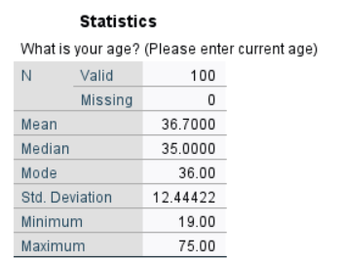
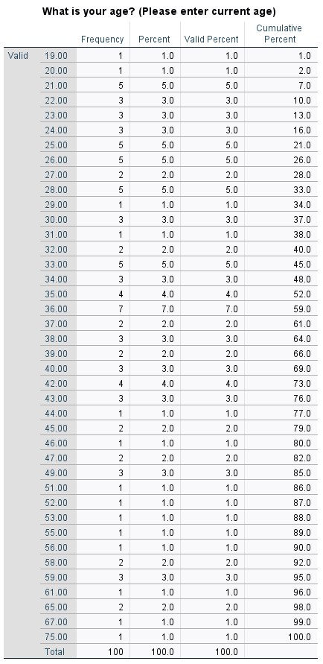
Profile of the Sample – Gender (SPSS Output for Write-Up & Figure 2.0)
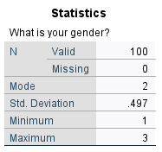
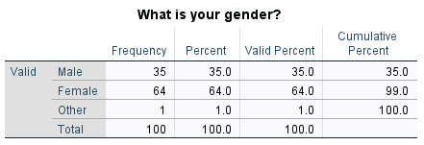
Profile of the Sample – Marital Status (SPSS Output for Write-Up & Figure 3.0)
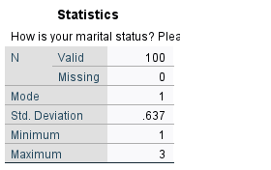
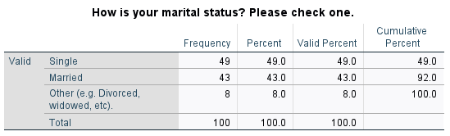

Profile of the Sample – Income (SPSS Output for Write-Up & Figure 4.0)
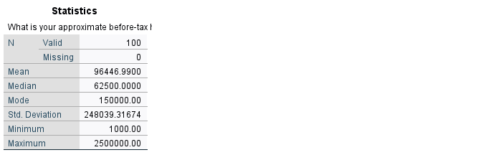
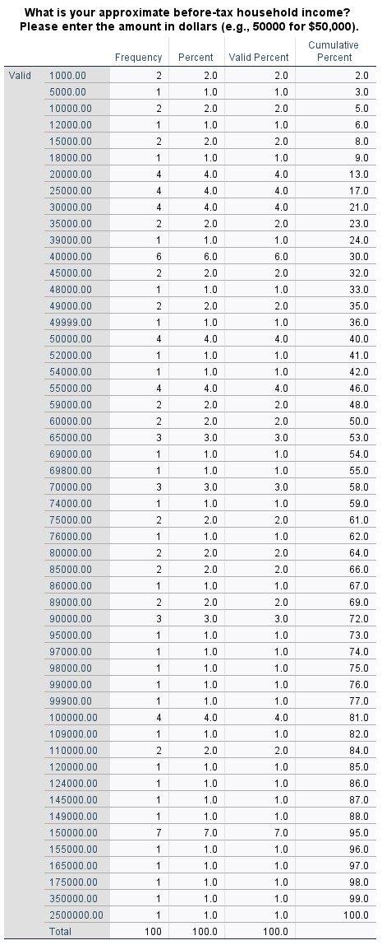
Profile of the Sample – Open-Ended Question (SPSS Output for Write-Up & Figure 5.0)
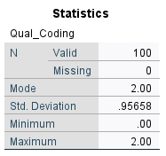
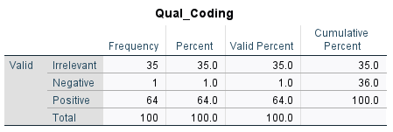

Objective 1: To measure the physical expansion of the company through the analyzation of the store layout.
1.1
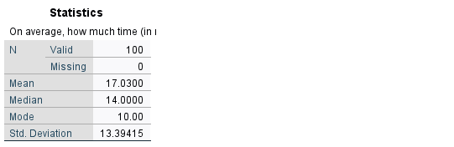
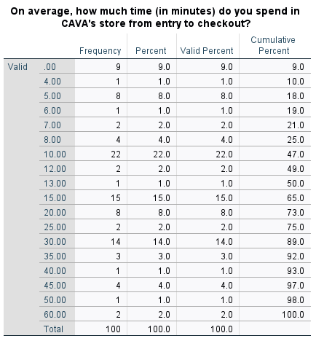
1.2
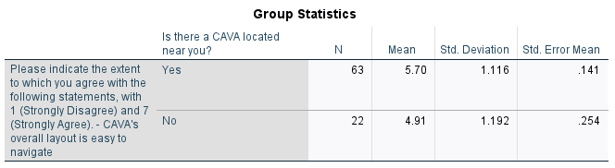
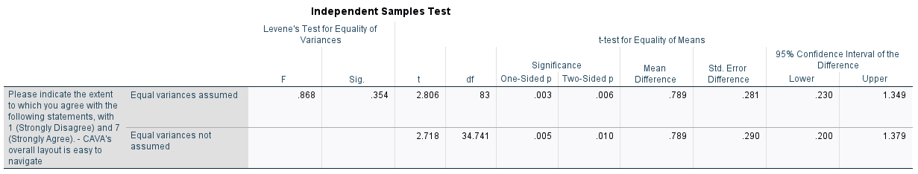
1.3
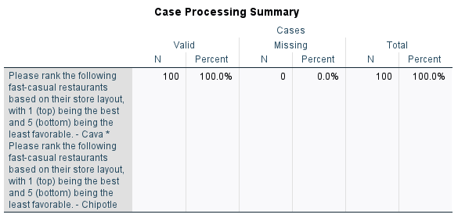
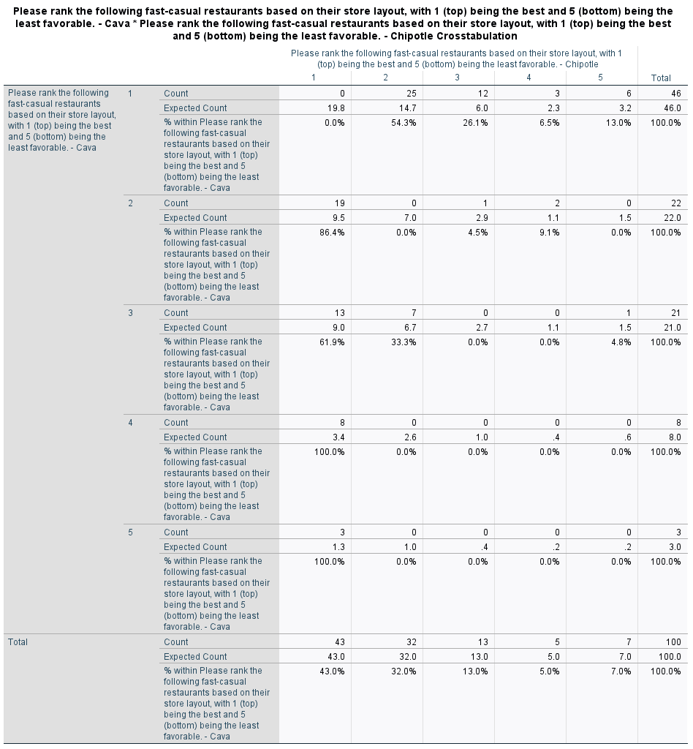
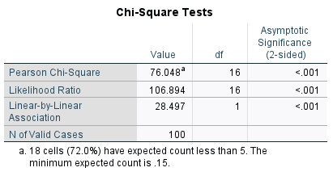
1.4
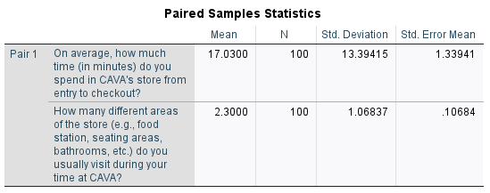
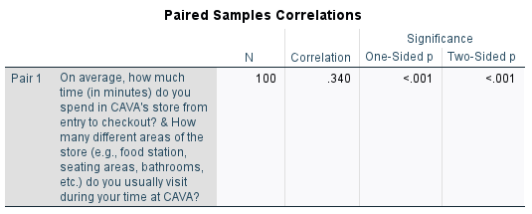
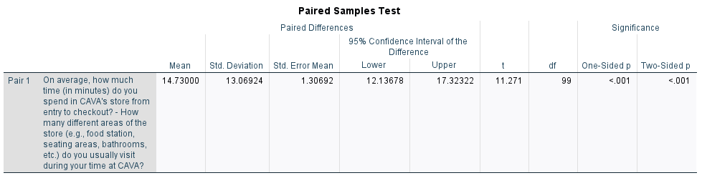
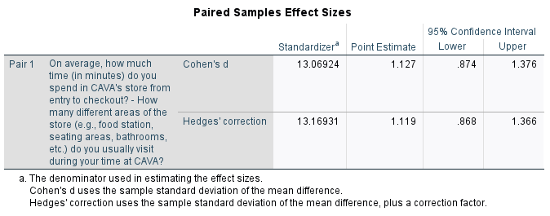

Objective 2: To measure customer experience and satisfaction across various fast-casual competitors to determine where CAVA is in consumers’ consideration set.
2.1
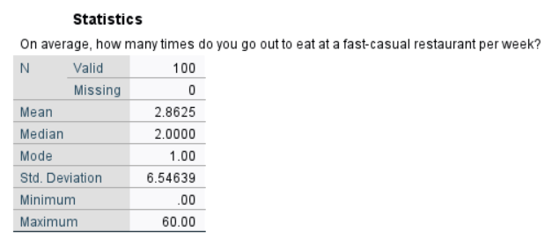
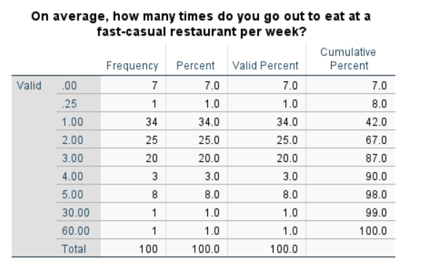

2.2
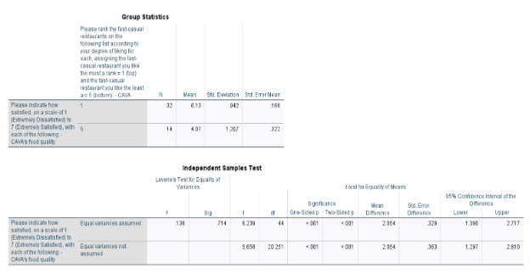
2.3
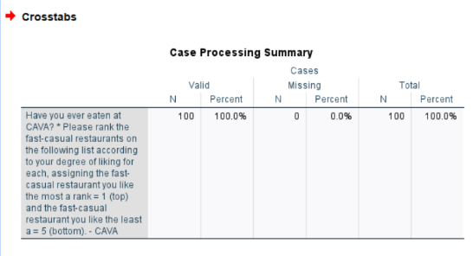
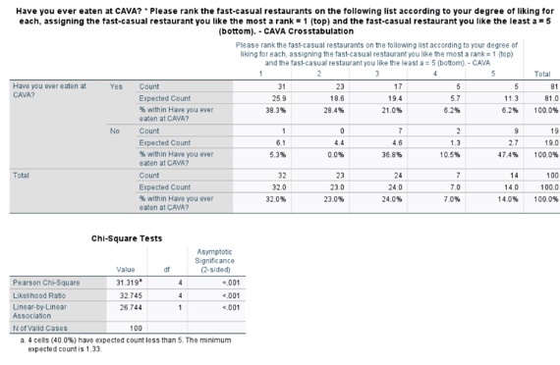

2.4
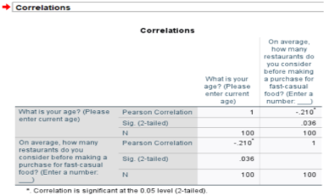
Objective 3: To identify legal threats that could impact consumer perceptions and prevent them from using the company’s products.
3.1
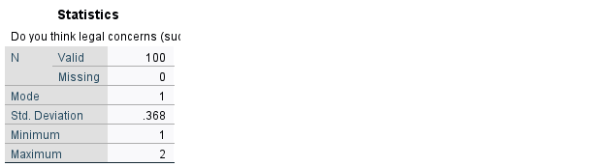
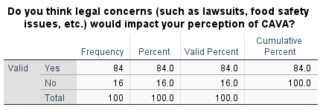
3.2
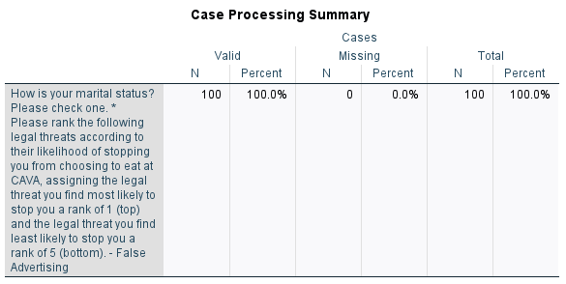
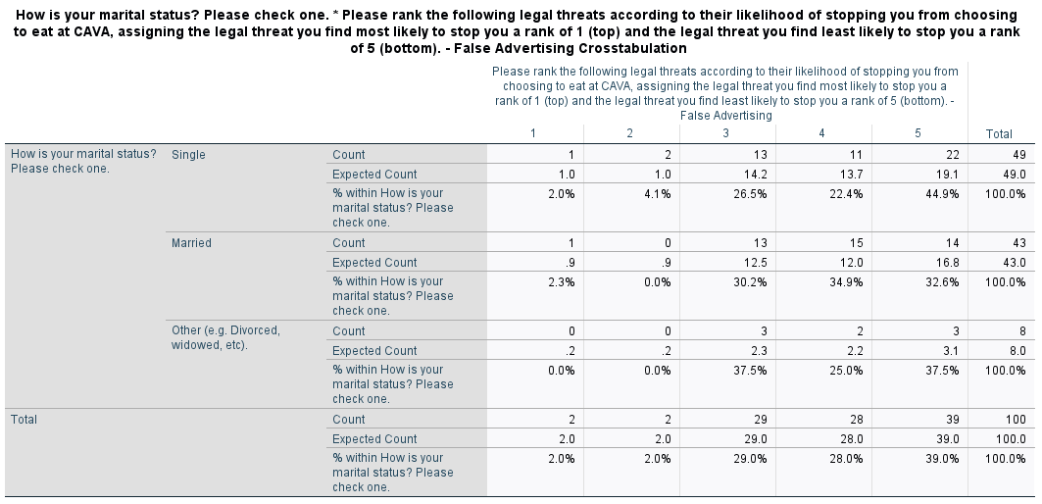
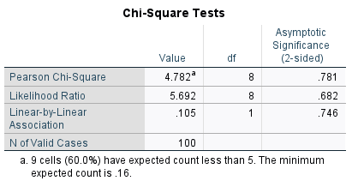
3.3
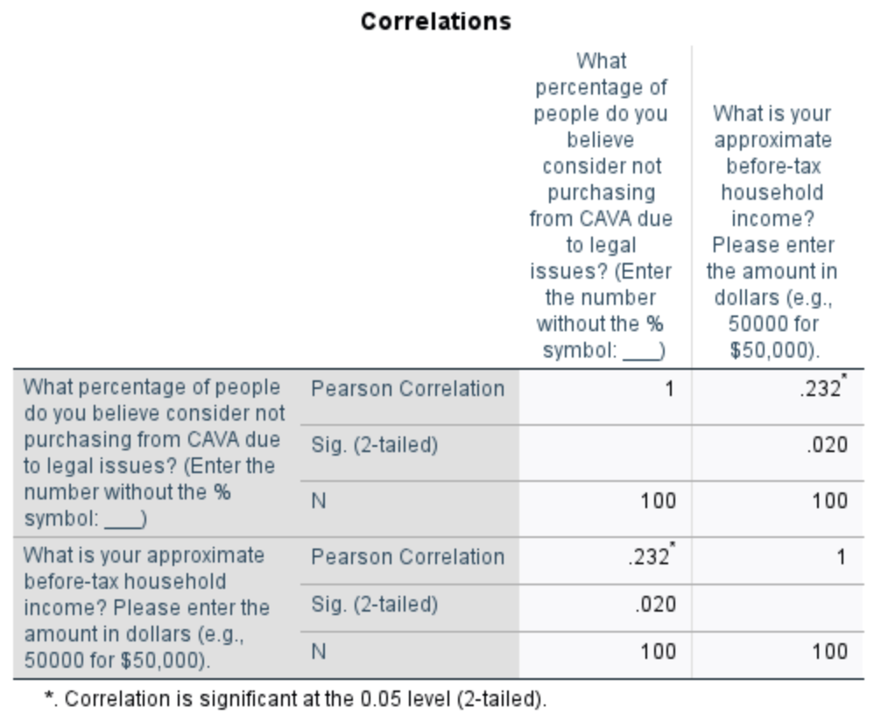
3.4
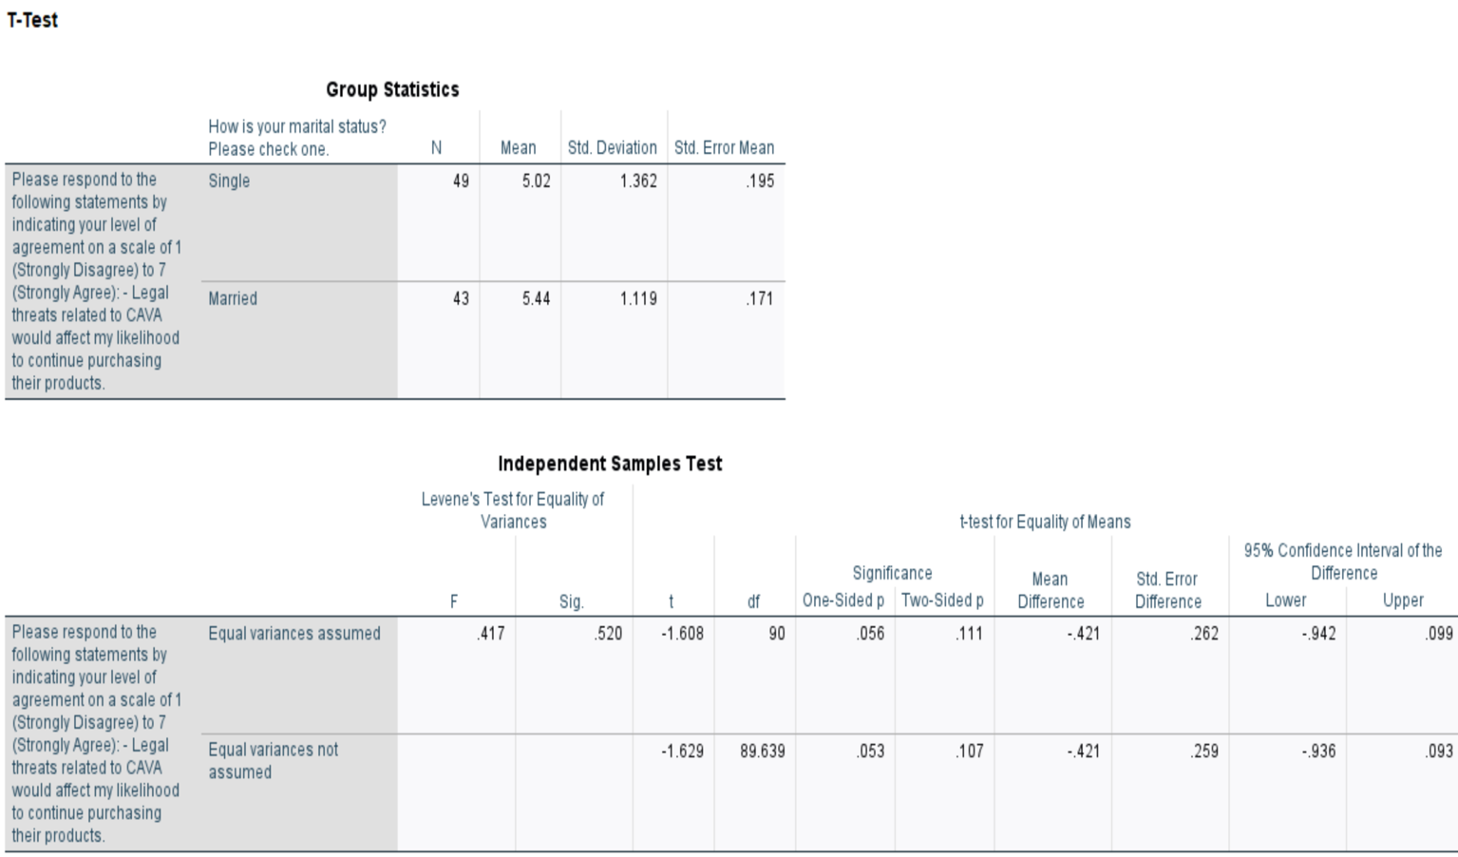

Objective 5: To assess consumer perceptions of CAVA’s pricing strategies in the context of current economic conditions to optimize future pricing and marketing strategies.
5.1
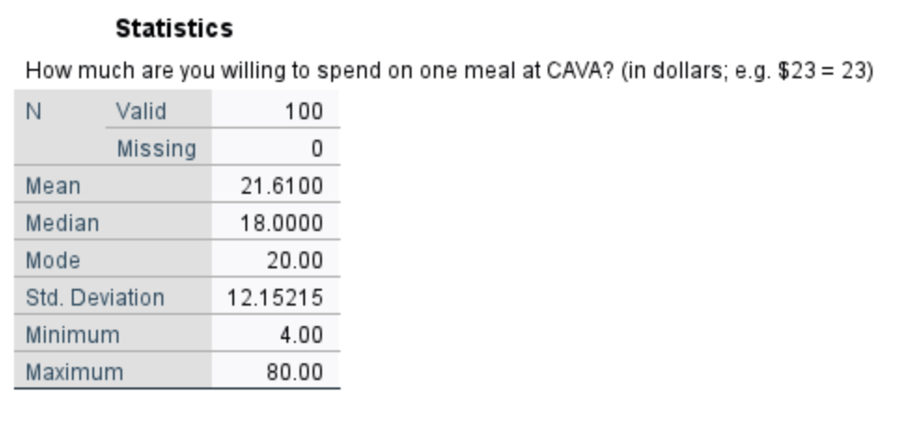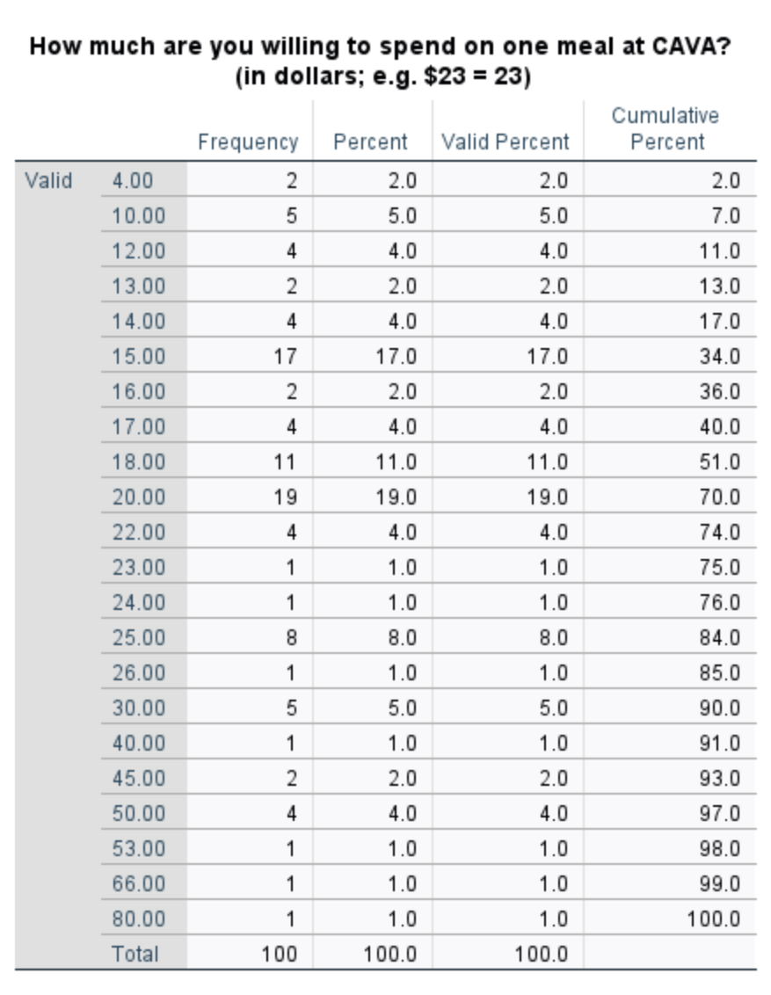
5.2
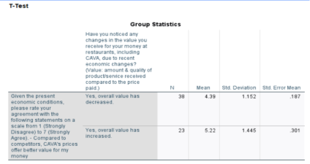
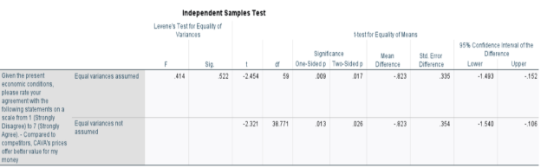

5.3
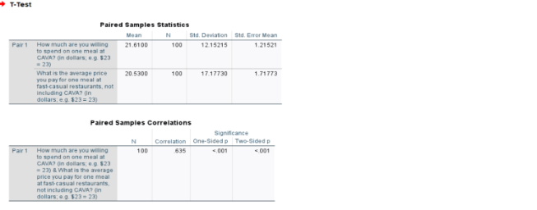
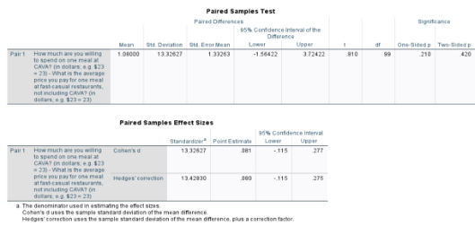

5.4
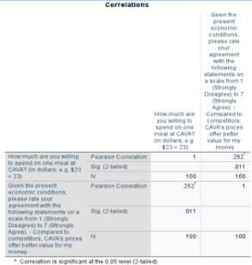
Objective 6: To analyze and identify CAVA’s major consumer segments by examining their attitudinal characteristics.
6.1
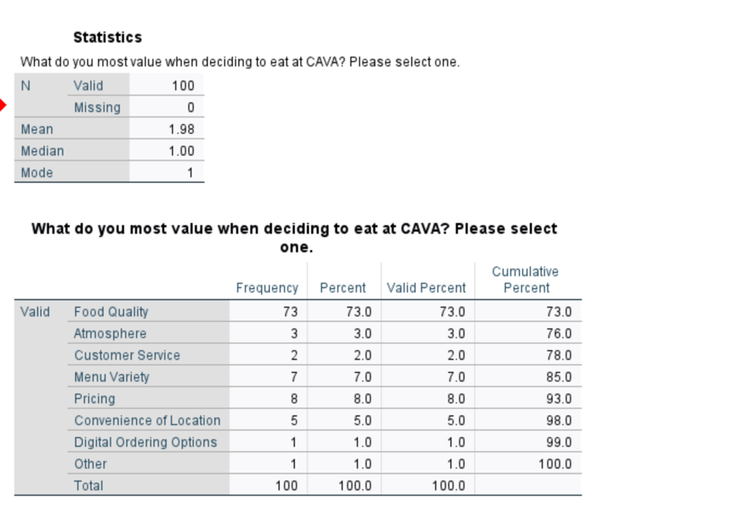
6.2
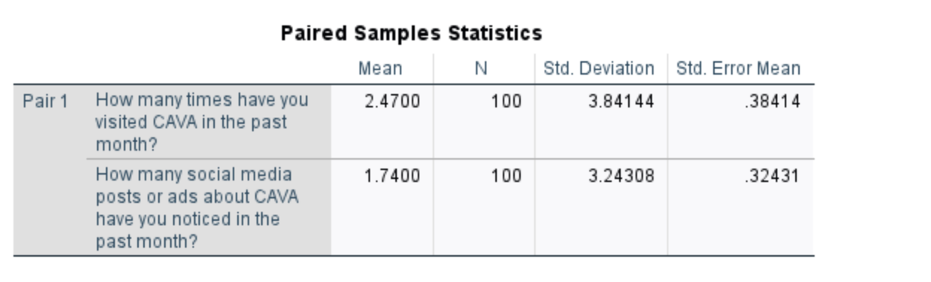
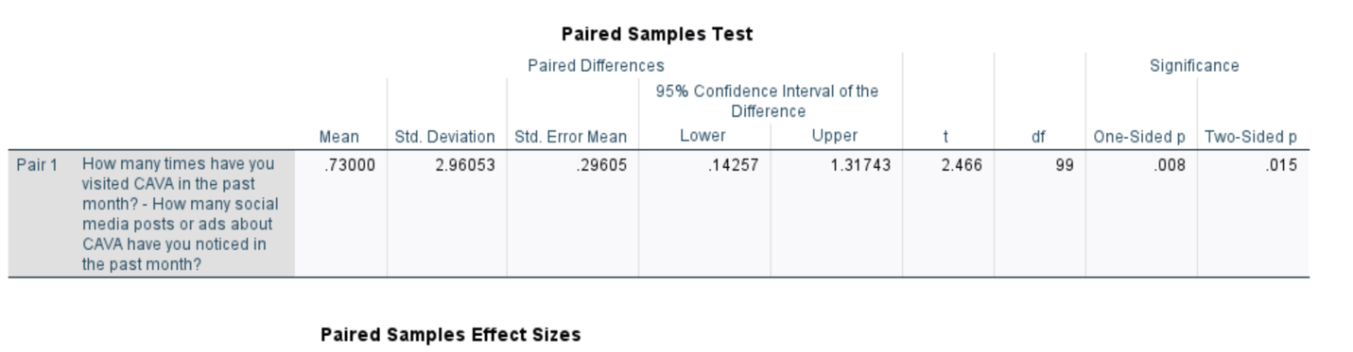
6.3
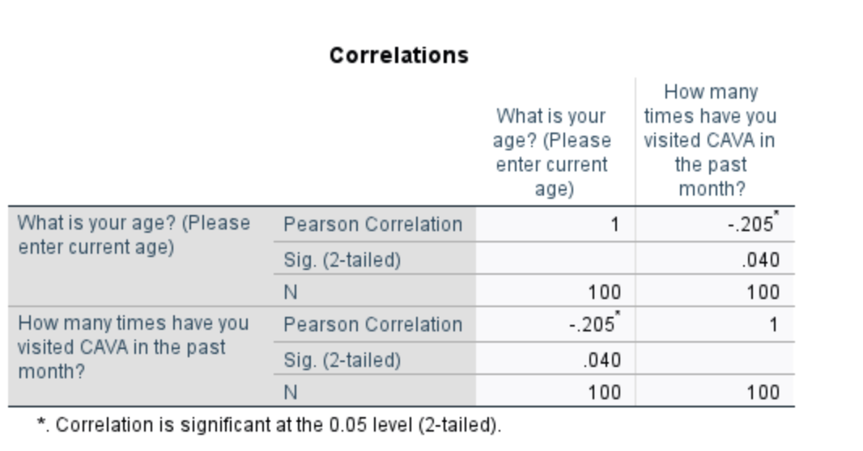

6.4
